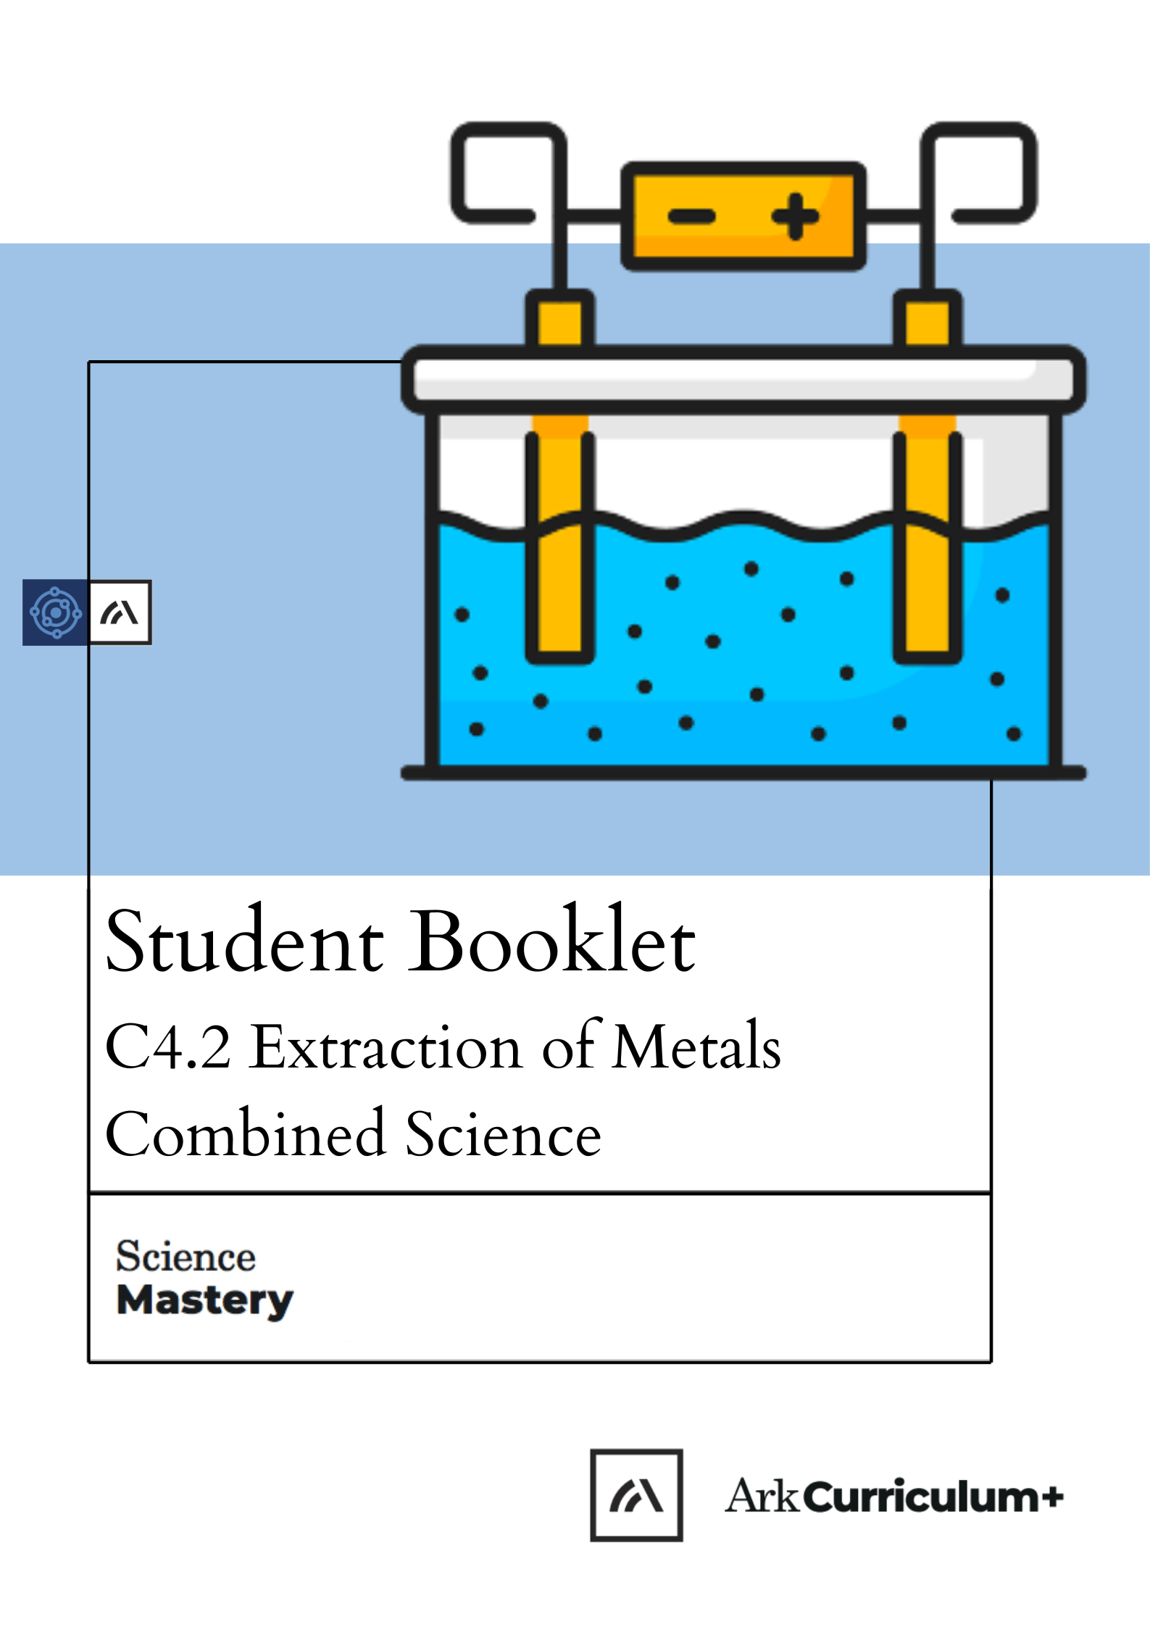


Extraction of Metals
The Big Idea
How are metals extracted? Are all metals obtained in the same way?
Some metals are more reactive than others. Some metals are found in ores, and some are found as pure metals in the Earth’s crust. Different metals require different chemical processes to extract them from their ores. In order to conserve natural resources, we can recycle metals.

This is the sixth unit we are studying as part of the big idea: Reactions Rearrange Matter.

In this unit we will learn about some of the common reactions of metals. We will be able to represent these reactions with word and balanced chemical equations.
We will be able to describe displacement reactions, which are one type of reaction used to extract a metal from an ore. Some students will be able to represent these reactions with new types of chemical equations: ionic equations and half equations.

You will study a technique called electrolysis. This is used to extract the most reactive metals from their ores. You will carry out your own electrolysis reactions and be able to explain how this works by referring to the movement of ions.
Finally, we will learn about recycling metals, and the advantages and disadvantages of this.

TASKS:
What subject will this unit focus on? BIOLOGY CHEMISTRY PHYSICS
(circle the correct subject)

There are lots of keywords underlined above. List these into the two columns:

Words I know | Words I haven’t seen before

To answer before the unit:
- What are you most excited to learn about in this topic?
____________________________________________________________________________________________________________________________________________________________________________________

- What do you already know about this topic?
____________________________________________________________________________________________________________________________________________________________________________________

- Why do you think it’s important to learn that structure determines properties?
____________________________________________________________________________________________________________________________________________________________________________________

- What knowledge from previous science lessons might help us?
____________________________________________________________________________________________________________________________________________________________________________________

- What questions do you have about this topic?
____________________________________________________________________________________________________________________________________________________________________________________

To answer at the end of the unit:
- Tick off any words in the ‘words I haven’t seen before’ column that you are now confident with. Circle any you still need more practice to use.

- What have you most enjoyed about this unit?
____________________________________________________________________________________________________________________________________________________________________________________

- What more would you like to learn about extracting metals as part of the big idea: ‘Reactions Rearrange Matter?
________________________________________________________________________________________________________________________

Pre-Test

- Choose the correct general word equation for the reaction of metals and acid. [1]
Tick ( ) one box.
- Acid + metal à salt + water | 
- Acid + metal à salt + hydrogen
- Acid + metal à salt + carbon dioxide

- The diagram below shows ways to save the limited resources that are on Earth.

2.
1.
A

Complete the gaps in the diagram. [1]
Tick ( ) one box.
- 1 = recycle 2 = reduce
- 1 = reduce 2 = recycle
- 1 = recycle 2 = reuse
- 1 = reuse 2 = recycle

- The atomic structure of metals relates to their position on the Periodic Table.
In which group of the Periodic Table would you find the element represented by this electronic configuration? [1]
Tick ( ) one box.
- Group 2
- Group 3
- Group 1

- A finite resource is a resource that… [1]
Tick ( ) one box.
- is being used up more quickly than it is being made.
- is being made more quickly than it is being used up.
- is running out.

- Choose which describes a property of alkali metals. [1]
Tick ( ) one box.
- Unreactive
- Very high melting point
- Soft
- Choose the product of the following chemical reaction.

Lithium + fluorine [1]
Tick ( ) one box.
- Lithium fluorate
- Lithium fluoride
- Lithium fluorine

- Choose the correct electronic configuration of a sodium atom.

The atomic number of sodium is 11. [1]
Tick ( ) one box.
- 2,8,1
- 2,9
- 4,7
- Choose the best explanation for why distillation isn’t often used to obtain drinking water from salt-water. [1]
Tick ( ) one box.
- The boiling points of water and salt are very close so they are hard to separate accurately by distillation
- Only small volumes can be distilled
- It is very expensive due to the energy required
- This box shows the reactivity series.
Potassium
Sodium
Calcium
Aluminium
Carbon
Iron
Tin
Lead
Hydrogen
Silver
Gold
Platinum
Increasing
reactivity
Choose a metal that would displace aluminium from aluminium oxide. [1]
Tick ( ) one box.
- Iron
- Platinum
- Sodium

- Iron oxide is an iron ore found on Earth.

Choose which method would extract the iron from iron oxide. [1]
Tick ( ) one box.
- React with a more reactive metal to displace the iron
- Filter the iron oxide to separate out the iron
- Add an acid to separate the iron and the oxygen
End of Unit Pre-Test. Turn over to see the answers. Give yourself a mark out of 10.
Prior Knowledge Review: Reactions of Metals
Knowledge Organiser

- Metals can be arranged in order of their reactivity in a reactivity series.
- Metals react with oxygen to produce metal oxides.
- The reactions are oxidation reactions because the metals gain oxygen.
- A reactivity series is a list of metals in order of most reactive (at the top) to least reactive (at the bottom)
- The metals potassium, sodium, lithium, calcium, magnesium, zinc, iron and copper can be put in order of their reactivity from their reactions with water and dilute acids.
- Some metals are unreactive. This means they do not easily take part in chemical reactions
- Some metals are reactive. This means they readily take part in chemical reactions
- The chemical formula for hydrochloric acid is HCl
- The chemical formula for nitric acid is HNO₃
- The chemical formula for sulfuric acid is H₂SO₄
- Acids react with some metals to produce salts and hydrogen gas
- Acids are neutralised by alkalis (e.g. soluble metal hydroxides) and bases (e.g. insoluble metal hydroxides and metal oxides) to produce salts and water, and by metal carbonates to produce salts, water and carbon dioxide
- All alkalis release hydroxide ions, OH-, into solutions
- Alkalis and bases can be metal oxides or metal hydroxides

Extracting Less Reactive Metals
- Unreactive metals such as gold are found in the Earth as the metal itself
- Most metals are found as compounds that require chemical reactions to extract the metal.
- Metals less reactive than carbon can be extracted from their oxides by reduction with carbon.
- Reduction involves the loss of oxygen.
- The non-metals hydrogen and carbon are often included in the reactivity series.
- A more reactive metal can displace a less reactive metal from a compound.
- We can use chemical equations to identify substances which are oxidised or reduced in a chemical reaction

Prior Knowledge Review: Ions, Ionic Bonding and Deducing Ionic Formulae
- When a metal atom reacts with a non-metal atom, electrons in the outer shell of the metal atom are transferred.
- Metal atoms lose electrons to become positively charged ions.
- Non-metal atoms gain electrons to become negatively charged ions.
- The ions produced by metals in Groups 1 and 2 and by non-metals in Groups 6 and 7 have the electronic structure of a noble gas (Group 0).
- The electron transfer during the formation of an ionic compound can be represented by a dot and cross diagram.
- The charge on the ions produced by metals in Groups 1 and 2 and by non-metals in Groups 6 and 7 relates to the group number of the element in the periodic table.

(HT only) Ionic Equations and Displacement Reactions
- Oxidation is the loss of electrons and reduction is the gain of electrons.
- When metals react with other substances the metal atoms form positive ions.
- The reactivity of a metal is related to its tendency to form positive ions
- A balanced equation for a displacement reaction can be written in terms of the ions involved
- Ions that appear on both sides of the equation do not take part in the reaction, and so the equation can be written without them.
Zn_{(s)} + 2H⁺_{(aq)} → H_{2(g)} + Zn²⁺_{(aq)}

(HT only) Ionic Equations and Displacement Reactions
- A balanced ionic equation can be split into two half equations. An example is shown below:
Fe_{(s)} → Fe²⁺_{(aq)} + 2e⁻

Cu²⁺_{(aq)} + 2e⁻ → Cu_{(s)}

- A redox reaction is one in which oxidation and reduction happen at the same time

(HT only) Ionic Equations for the Reactions of Acids and Metals

- The reactions of acids with metals are redox reactions
- The reaction between magnesium and hydrochloric acid can be represented by the word equation: magnesium + hydrochloric acid magnesium chloride + hydrogen

Introduction to Electrolysis
- When an ionic compound is melted or dissolved in water, the ions are free to move about within the liquid or solution.
- These liquids and solutions are able to conduct electricity and are called electrolytes.
- Passing an electric current through electrolytes causes the ions to move to the electrodes.
- Electricity is the flow of electrons or ions
- Positively charged ions move to the negative electrode (the cathode), where they receive electrons and are reduced.
- Negatively charged ions move to the positive electrode (the anode), where they lose electrons and are oxidised.

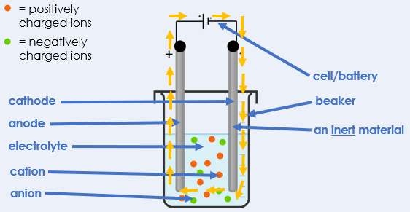
- For electrolysis to work, the compound must contain ions
- The ions must be free to move, which is possible when an ionic substance is dissolved in water or melted.
- Electrolysis is the process by which ionic substances are decomposed into simpler substances when an electric current is passed through them

Extracting Metals by Electrolysis
- Metals can be extracted from molten compounds using electrolysis.
- Electrolysis is used if the metal is too reactive to be extracted by reduction with carbon or if the metal reacts with carbon.
- Large amounts of energy are used in the extraction process to melt the compounds and to produce the electrical current.
- Aluminium is manufactured by the electrolysis of a molten mixture of aluminium oxide and cryolite using carbon as the positive electrode (anode).
- To prepare for electrolysis, the aluminium ore is dissolved in molten cryolite instead of being melted.
- This is because melting aluminium ore would be too expensive a process, due to the high costs of energy to heat to the high temperature that would be required.

Electrolysis of Molten Ionic Compounds
- Ions are discharged at the electrodes producing elements.
- Half equations can be written for the reactions at each electrode in electrolysis
- When a simple ionic compound (e.g. lead bromide) is electrolysed in the molten state using inert electrodes, the metal (lead) is produced at the cathode and the non-metal (bromine) is produced at the anode.

Electrolysis in Solutions
- The ions discharged when an aqueous solution is electrolysed using inert electrodes depend on the relative reactivity of the elements involved.
- At the negative electrode (cathode), hydrogen is produced if the metal is more reactive than hydrogen.
- At the positive electrode (anode), oxygen is produced unless the solution contains halide ions when the halogen is produced.
- This happens because in the aqueous solution water molecules break down producing hydrogen ions and hydroxide ions that are discharged.
- Reactions at electrodes can be represented by half equations, for example: 2H⁺ + 2e⁻ → H₂

(HT only) Obtaining Raw Materials
- The Earth’s resources of metal ores are limited.
- Copper ores are becoming scarce and new ways of extracting copper from low-grade ores include phytomining, and bioleaching.
- These methods avoid traditional mining methods of digging, moving and disposing of large amounts of rock.
- Mining destroys wildlife habitats
- Phytomining uses plants to absorb metal compounds. The plants are harvested and then burned to produce ash that contains metal compounds.
- Phytomining conserves supplies of ores
- Bioleaching uses bacteria to produce leachate solutions that contain metal compounds.
- The metal compounds can be processed to obtain the metal.
- For example, copper can be obtained from solutions of copper compounds by displacement using scrap iron or by electrolysis.
- Obtaining raw materials from the Earth by quarrying and mining causes environmental impacts.

Recycling Materials
- Metals can be recycled by melting and recasting or reforming into different products.
- The amount of separation required for recycling depends on the material and the properties required of the final product. For example, some scrap steel can be added to iron from a blast furnace to reduce the amount of iron that needs to be extracted from iron ore.
Glossary
Anode | The positively charged electrode used in electrolysis.  Negatively charged ions such as fluoride ions are attracted to the anode.
Bioleaching  (HT only) | A process that uses bacteria to produce leachate solutions that contain metal compounds.  Bacteria carry out bioleaching to extract copper ions from ores.
Cathode | The negatively charged electrode used in electrolysis.  Positively charged ions such as sodium ions are attracted to the cathode.
Corrosion | The destruction of materials by chemical reactions with substances in the environment.  Rusting is an example of corrosion.
Cryolite | A compound that reduces the melting point of aluminium oxide,  Cryolite is used for the electrolysis of molten aluminium oxide.
Discharged | When ions gain or lose electrons to form neutral atoms or molecules.  Sodium ions are discharged at the cathode during electrolysis.
Displacement reaction | A reaction where a more reactive element replaces a less reactive element in a compound.  A displacement reaction takes place when carbon reacts with iron oxide.
Electrode | A conductor through which electricity can flow.  Anodes and cathodes are conductors and can be made of graphite.
Electrolysis | The process of passing an electric current through a substance, to split it up into its ions.​  Electrolysis requires an electrolyte, electrodes and a power source.
Electrolyte | A liquid containing ions that current is passed through during electrolysis.  An aqueous solution of sodium chloride is an example of an electrolyte.
Electron | A negatively charged subatomic particle that orbits the nucleus of an atom.  In ionic bonding electrons are transferred from one atom to another.
Electroplating | Adding a thin layer of metal to an object using electrolysis.  A metal spoon can be electroplated with silver.
Empirical formula | The simplest ratio of atoms of each element in a compound.  The empirical formula of calcium hydroxide is Ca(OH)₂.
Extracted | To take something out  Aluminium can be extracted from its ore, aluminium oxide, using electrolysis.
Half equation (HT only) | A rock that contains enough metal compound to extract the metal.  Haematite is a common iron oxide ore.
Ion | A charged particle or group of particles.  A sodium ion has a positive charge.
Ionic bonding | Ionic bonding occurs in compounds formed from metals combined with non-metals. Electrons are lost or gained to form a stable electronic configuration.  Ionic bonding occurs in sodium chloride because sodium is a metal and chlorine is a non-metal. As sodium chloride forms, an electron is transferred from a sodium atom to a chlorine atom, forming Na⁺ and F⁻ ions.
Ionic equation  (HT only) | A balances symbol equation that shows the reacting ions in a chemical reaction.  Ionic equations allow us to see more easily what has been oxidised and what has been reduced in a reaction..
Low-grade ore | An ore that contains a very low percentage of the metal or compound to be extracted.  Most nickel ores are low-grade ores.
Mining | The digging and moving of rock from the Earth.  Mining is needed to obtain metal ores but it can be destructive to wildlife.
Molten | When a substance has been heated so it is a liquid.  Molten aluminium oxide can be electrolysed.
Ore | A rock that contains enough metal compound to extract the metal.  Haematite is a common iron oxide ore.
Oxidation | When electrons are lost.  When a magnesium atom is oxidised, it loses two electrons and becomes a Mg²⁺ ion.
Phytomining  (HT only) | An extraction process that uses plants to absorb metal compounds. The plants are harvested and then burned to produce ash that contains metal compounds.  Phytomining is used to extract copper from copper ores.
Pure | A substance that is made from only one type of particle.  Pure, molten aluminium oxide only contains aluminium ions and oxide ions.
Recasting/  reforming | When molten, recycled metal is used to form something new.  During the recycling process, molten aluminium can be recast to form cans.
Recycling | When a substance is collected and processed to form a usable material.  Metals can be recycled by melting and recasting or reforming into different products.
Redox | A reaction in which oxidation and reduction take place at the same time​  When a metal and oxygen react, a redox reaction occurs.
Reduction | When electrons are gained.  When a chlorine atom is reduced, it gains two electrons and becomes a Cl ²⁻ ion.
Rusting | The corrosion of iron.  Iron rusts when it reacts with oxygen.
Spectator ions | Ions that are the same in the reactants and the products.  Spectator ions are excluded when we write ionic equations.
Sustainable | Recycling and reusing materials when there is a limited amount of the material on Earth.  Recycling metals ensures the sustainable use of metals.
Valence electron(s) | Electrons in the outer shell of an atom or ion.  A fluorine atom has 7 valence electrons.

Prior Knowledge Review: Reactions of Metals
Do Now
1. Define ‘the reactivity series’.
2. Where does gold appear on the reactivity series?
3. Define ‘oxidation’.
4. Define ‘reduction’.
5. What name is given to minerals that contain enough metal to be extracted economically?

Drill:
- Put potassium, copper and carbon in order of reactivity.
- Why does copper oxide react with carbon?
- Name the two products of this reaction.
Read Now:
Nikolai Beketov was a Russian scientist, born in 1827. He was a chemist and metallurgist.
Beketov determined the reactivity series of metals. He discovered the displacement of metals from solutions of their salts, using hydrogen. He also established that magnesium and zinc displaced other metals from their salts. In 1864, Beketov organised the department of physical chemistry at Kharkiv University, and taught the first course in physical chemistry as an independent subject.
Kharkiv University is located in the North-East of Ukraine. In March 2022, many of the University buildings were heavily damaged due to the Russian invasion into Ukraine.
1. Where was Nikolai Beketov from?
2. What subjects did Beketov study?
3. What did Beketov discover?
4. In which University did Beketov work?
5. Which topic did Beketov teach as an independent subject for the first time?

Drill

- What is the reactivity series?
- Where are the most reactive metals in the reactivity series?
- Where are the least reactive metals in the reactivity series?
- What is produced when an acid reacts with a metal?
- What is produced when an acid reacts with a metal carbonate?
- Give an example of a base.
- What will be observed with an acid reacts with a metal carbonate
- What is the chemical formula for hydrochloric acid?
- What is the chemical formula for sulphuric acid?
- Write a word equation for the reaction between nitric acid and magnesium.

The Reactivity Series

Potassium MOST REACTIVE
Sodium
Calcium
Magnesium
Aluminium
(Carbon)
Zinc
Iron
Lead
(Hydrogen)
Copper
Silver
Gold
Platinum LEAST REACTIVE

Use the reactivity series to predict whether a reaction will take place and how intense the reaction will be.
Metal | Reacting with | Prediction
Silver | Acid
Sodium | Water
Gold | Oxygen
Potassium | Oxygen

Write the general equation for the reaction between an acid and alkali

Write the general equation for the reaction between an acid and base

Write the general equation for the reaction between an acid and metal carbonate

How might your observations be different for the two reactions above?

Complete the equations below:
- Acids + alkali/base →
- Acids + metal carbonates →
- Hydrochloric acid + lithium oxide →
- Nitric acid + magnesium hydroxide →
- Sulfuric acid + copper carbonate →
- Hydrochloric acid + calcium carbonate →

Exit Ticket
- What do all acids have in common?
- A. They are all corrosive
- B. They all have a pH of greater than 7
- C. They all release hydrogen ions (H+) into solutions
- D. They all release hydroxide ions (OH-) ions into solutions

2. In a reaction between a metal and an acid, what will always be produced?
- A. a salt and carbon dioxide
- B. a salt and water
- C. a salt and hydrogen gas
- D. a salt, water and carbon dioxide

3. . What is the reactivity series?
- A. It is a list of metals ordered from most reactive at the top to least reactive at the bottom
- B. It is a list of metals ordered from least reactive at the top to most reactive at the bottom
- C. It is a list of metals with different reactivities (some are more reactive than others)

Extracting Less Reactive Metals
Do Now:
1. What metal undergoes rusting?
2. What other substances are required for this metal to rust?
3. What is formed when a metal reacts with an acid?
4. When hydrogen gas is produced, what might be observed during the reaction? ()
5. Write down the symbol used to separate the reactants and products in a chemical reaction.

Drill:

- Write the word equation for the reaction of magnesium metal with hydrochloric acid.
- The chemical formula for Magnesium chloride is MgCl₂. Write a balanced chemical equation for the same reaction.

Read Now:

Africa is swiftly becoming the second largest gold mining region in the world, after China. A number of African countries are beginning to increase gold exploration, with five countries topping the list – Ghana, South Africa, Sudan, Mali and Burkina Faso. In 2021, over 680 tonnes of gold was mined in Africa (an increase of 0.5% on the previous year). So what is special about gold? Gold is a soft and dense previous metal that is the most malleable out of all metals. It is an excellent conductor of electricity. This means that it has many uses, including for jewellery, and industry.

      - Where in the world is the most gold mined each year?
      - List the five African countries that mine the most gold per year.
      - State a property of gold.
      - Describe a use of gold.
      - Calculate the mass of gold mined in Africa in 2020.

Drill

- What is the type of reaction used to extract the least reactive metals from their ores?
- What is the most reactive metal in the reactivity series?
- Give one observation a student would make in the reaction between zinc and copper sulfate.
- Define oxidation.
- Define reduction.
- Which metals can copper displace from a compound?
- Write an equation for the displacement reaction between carbon and copper oxide.
- Explain why there would be no reaction between carbon and aluminium oxide.
- Which is less reactive, zinc or lead?
- Write a balanced chemical equation for the reaction between carbon and copper oxide (CuO).

We:
Ancient Roman coins made of copper have been found.
One step in the manufacture of copper is the reduction of capper oxide (CuO) with carbon.
1. What are the products of this reaction?

2. Write a word equation to describe this reaction.

3. Write a balanced chemical equation for this reaction.

4. Give one observation that would be made that would indicate that a reaction is happening.

You:
Iron is sometimes used to make railings.
One step in the manufacture of lead is the reduction of iron oxide (Fe₂O₃) with carbon.
1.What are the products of this reaction?

2. Write a word equation to describe this reaction.

3. Write a balanced chemical equation for this reaction.

4. Give one observation that would be made that would indicate that a reaction is happening.
Exit Ticket

- Which answer correctly describes the reaction between lithium and aluminium oxide?
- A. lithium + aluminium oxide -> lithium aluminium + oxygen
- B. lithium + aluminium oxide -> lithium oxide + aluminium
- C. lithium and aluminium oxide would not react

- Which of the metals below would be found as a pure metal in the Earth's crust?
- A. Aluminium
- B. Gold
- C. Copper oxide (an ore)

- The combustion of magnesium can be represented by the following equation:
2 Mg + O2 -> 2MgO

What type of reaction is this?
- A. A reduction reaction
- B. An oxidation reaction
- C. A neutralisation reaction

Ions, Ionic Bonding and Deducing Ionic Formulae

Do Now
            - Name three types of bonding.
            - What type of elements does ionic bonding occur between? .
            - Write the number 132000 in standard form.
            - What is a covalent bond?
            - Write down the electronic configuration of a neon atom.

Drill:
- What word means ‘a charged atom or group of atoms’?
- What are ions able to do in a metal, which explains why metals can conduct electricity?
- State the type of bonding in a hydrogen molecule (H₂)

Read Now:
Ever since the first airplane flight (over 100 years ago), the science of flight has progressed. Now, we can fly using many different kinds of aircraft including planes, drones and helicopters. All of these methods of flight have one thing in common – they require moving parts. Now, engineers have built and flown the first ever plane that doesn’t need moving parts. Instead, it uses ionic wind – a silent but mighty stream of ions. Ions are charged atoms, or groups of atoms. This ionic wind generates enough thrust to propel the plane into flight. In contrast to traditional aircraft, it requires no fossil fuels to run, and it’s completely silent!
1. How long ago was the first airplane flight?
2. List three examples of aircraft.
3. What do all traditional types of aircraft have in common?
4. What is an ion?
5. Why might this new technology be better than the existing technology?
Drill

- What is the difference between a sodium atom and a sodium ion?
- Do metal atoms lose or gain electrons?
- How many valence electrons does an atom of chlorine have?
- What charge ions will atoms in group 7 of the Periodic table form?
- For metals, what is the relationship between the group number and the charge on the ion?
- For non-metals, what is the relationship between the group number and the charge on the ion?
- How many atoms of sodium would react with an atom of fluorine?
- How many atoms of sodium would react with an atom of oxygen?
- Why are electrons drawn with different symbols for each atom?
- Explain the answer to question 7.

Task

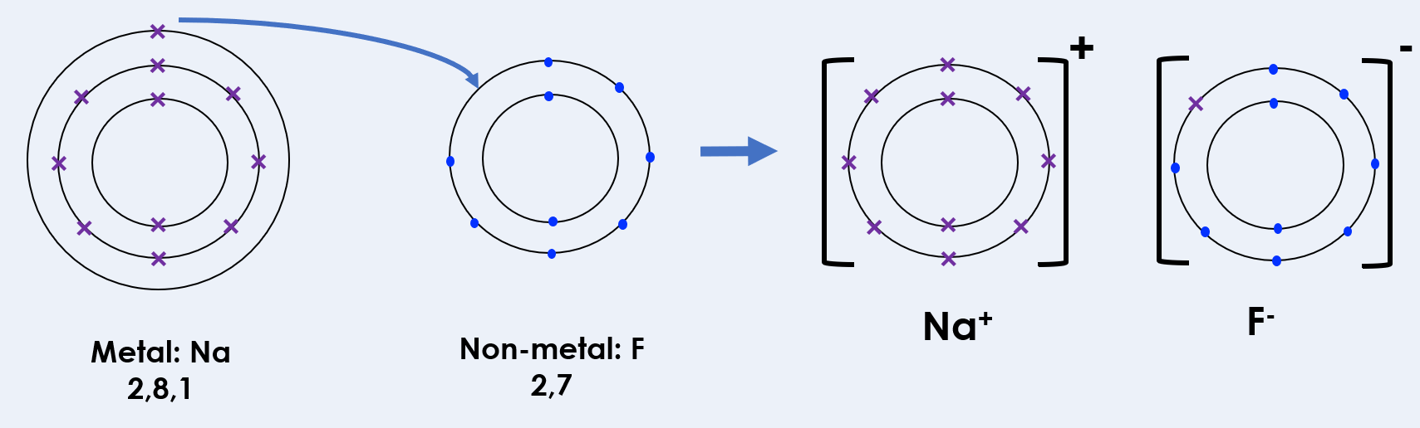

To draw dot and cross diagrams for ionic bonding, the steps here for NaF:

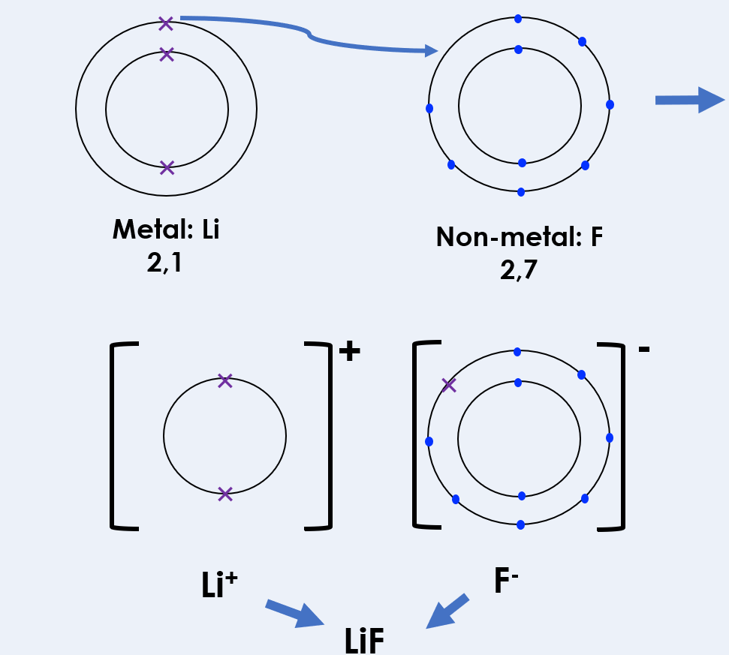

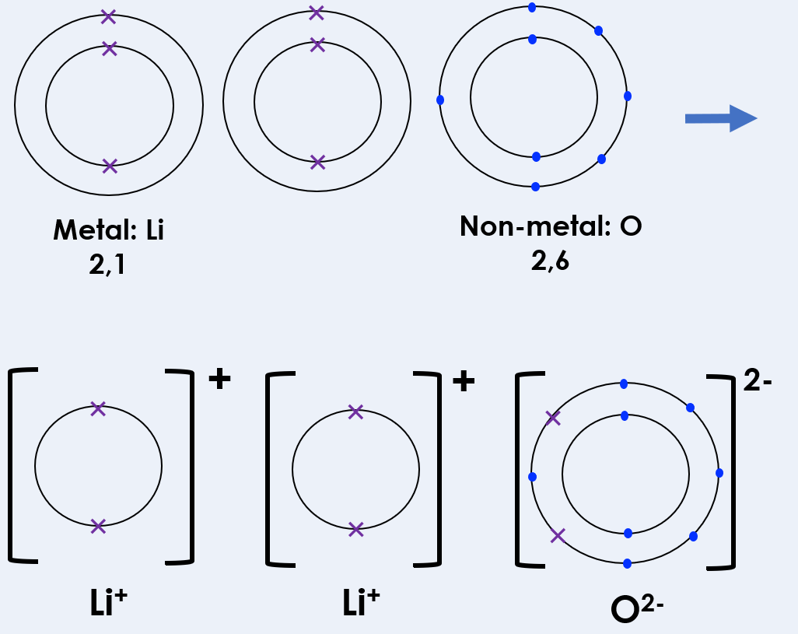

We: Describe how ionic bonding has occurred in lithium oxide using dot-and-cross diagrams above.

You: Describe how ionic bonding has occurred in lithium oxide using dot-and-cross diagrams above.

Exit Ticket

- Which answer correctly shows a sodium ion?
- A. Na
- B. Na⁺
- C. Na⁻

- Which statement is true?
- A. Metal atoms gain electrons to become positive ions
- B. Metal atoms gain electrons to become negative ions
- C. Metal atoms lose electrons to become positive ions
- D. Metal atoms lose electrons to become negative ions

- The ions within lithium chloride are listed below. What is the empirical formula of lithium chloride?
Li²⁺ Cl⁻ Cl⁻

- A. LiCl₂
- B. Li₂Cl
- C. LiCl

Do Now:
Ionic Equations and Displacement Reactions
1.Why do metal atoms generally form positive ions?
2. What group number are the Noble Gases on the Periodic Table?
3. What charge do the ions of group 1 elements have?
4. What charge do the ions of group 7 elements have?
5. Sodium oxide contains the ions Na⁺ and O²⁻. What is the chemical formula for sodium oxide?

Drill:
- Draw the electronic configuration for a sodium atom. Sodium:
- Draw the electronic configuration for a chlorine atom. Chlorine:
- Describe in terms of electrons what happens when a sodium atom reacts with a chlorine atom.

Read Now:
Imagining life without water is impossible, literally! It is the most abundant molecule on the Earth’s surface. Each molecule of water consists of two hydrogen atoms bonded to an oxygen atom, and we give this molecule the chemical formula H₂O. Pure liquid water at room temperature is odourless (it has no smell), tasteless (it has no taste), and almost colourless. It actually has a very faint blue colour, but we can only see this in very large volumes of water. Water has the second highest specific heat capacity of all substances. The specific heat capacity is the energy required to raise one kilogram of the substance by 1 degree Celsius. Water also acts as a solvent, because many substances can dissolve in water.
- What does one molecule of water consist of?
- What is the chemical formula for water?
- What word means something has no smell?
- Define ‘specific heat capacity’.
- Why is water often used as a solvent?
Complete the table below
A | B | Would A need to gain or lose electrons to become B? | How many electrons?
H_{(g)} | H⁺_{(aq)}
Na⁺_{(aq)} | Na_{(s)}
Cl_{2(g)} | 2Cl⁻_{(aq)}
Cu²⁺_{(aq)} | Cu_{(s)}
Mg_{(s)} | Mg²⁺_{(aq)}
Drill

- Define oxidation in terms of electrons
- Define reduction in terms of electrons
- List the ions that make up LiOH
- List the ions that make up Na₂O
- What must happen to Fe²⁺ to turn it into Fe?
- What is a redox reaction?
- Write an ionic equation for the following reaction:
Zn_{(s)} + CuCl_{2(aq)} → ZnCl_{2(aq)} + Cu_{(s)}
- Write the down the spectator ion in question 7
- State which species is oxidised in question 7
- State which species is reduced in question 7

We:
The equation for the displacement reaction between copper and silver nitrate is as follows:
Cu + 2AgNO₃ → 2Ag + Cu(NO₃)₂
Write an ionic equation for this reaction

2. Explain which species is oxidised in this reaction.

You:
The equation for the displacement reaction between potassium and copper nitrate is as follows:
2K_{(s)} + Cu(NO₃)_{2(aq)} → 2KNO_{3(aq)} + Cu_{(s)}
1. Write an ionic equation for this reaction

Explain which species is oxidised in this reaction.

Exit Ticket

- Define reduction.
- A. Reduction is the loss of oxygen or the gain of electrons
- B. Reduction is the loss of oxygen or the loss of electrons
- C. Reduction is the gain of oxygen or the gain of electrons
- D. Reduction is the gain of oxygen or the loss of electrons.

2. Magnesium reacts with copper (II) sulfate in a displacement reaction. The chemical equation for this reaction is Mg(s) + CuSO₄(aq) -> MgSO₄(aq) + Cu(s). What is the ionic equation for this reaction?
- A. Mg(s) + Cu²⁺⁽aq) + SO₄²⁻(aq)-> Mg²⁺⁽aq) + SO₄²⁻(aq)+ Cu(s)
- B. Mg(s) + Cu²⁺⁽aq) → Mg²⁺(aq) + Cu(s)
- C. 2Mg(s) + Cu²⁺⁽aq) → Mg²⁺(aq) + 2Cu(s)

3. . Sodium atoms are sometimes oxidised to become positively charged sodium ions. Why is this an oxidation reaction?
- A. Because oxygen is added to the sodium atoms
- B. Because oxygen is lost from the sodium atoms
- C. Because the sodium atoms lose electrons to become positively charged
- D. Because the sodium atoms gain electrons to become positively charged

Writing Half Equations
Do Now:
1. Define oxidation in terms of electrons.
2. Define reduction in terms of electrons.
3. True or false? A more reactive metal is more likely to form positive ions.
4. Sodium atoms (Na) are oxidised to Na⁺ ions in a reaction. Why is this an oxidation reaction?
5. Complete the general word equation to show the product of a reaction between a metal and oxygen.

Drill:
- State the formula for a chloride ion.
- Rewrite this ionic equation so that it is correct:
H⁺_{(aq)} + Cl⁻_{(aq)} + K⁺ _{(aq)} + OH⁻_{(aq)} → K⁺_{(aq)} + Cl⁻_{(aq)} + H₂O_{(l)}

Read Now:
Researchers at the University of Maryland in the US have found that a battery can be made from chitosan, a material in crab and shrimp shells, and zinc. The battery is rechargeable. The benefits of the battery include that it is safe, can be recharged up to 10,000 times, and it can be safely recycled. Scientists hope that this material could be an alternative to lithium-ion batteries. These are the batteries which we use in our phones, small and large appliances, smart watches, electric vehicles and in many other devices. Unfortunately, lithium-ion batteries contain polypropylene and polycarbonate which take hundreds of years to degrade. The amount of chitosan powder that would be needed to make a coin-sized battery would cost just 0.00015 p.
1. What is chitosan?
2. List 3 benefits of a battery made from chitosan.
3. Where do we use lithium-ion batteries?
4. State a disadvantage of lithium-ion batteries.
5. How much would it cost to purchase enough chitosan make a coin sized battery?
Drill

- What happens to metal atoms in order for them to form ions?
- What happens to Group 6 elements in order for them to form ions?
- How many ions will a beryllium atom lose in order to form an ion?
- What is the charge on a chloride ion
- Write down the formula for a nitrate ion
- Write a half equation that shows the following: a lithium atom loses one electron to become a lithium ion with the formula Li⁺
- Write a half equation that shows the following: a fluoride ion with the formula F⁻ loses an electron to form a fluorine atom.
- Rewrite the following half equation, adding in the state symbols: Na⁺ + e⁻ → Na
- For the half equation in question 8, state whether sodium ion is oxidised or reduced.
- Explain your answer to question 9.

We:
The ionic equation for a reaction is as follows:
Br_{2(s)} + 2Na⁺_{(aq)} + 2I⁻_{(aq)} → 2Na⁺_{(aq)} + 2Br⁻_{(aq)} + I_{2(s)}
Use this ionic equation to write two half equations.

You:
The ionic equation for a reaction is as follows:
Cl_{2(aq)} + 2K⁺_{(aq)} + 2Br⁻_{(aq)} → 2K⁺_{(aq)} + 2Cl⁻_{(aq)} + Br_{2(aq)}
Use this ionic equation to write two half equations.

Exit Ticket

- The reaction between magnesium and copper (II) sulfate can be represented by the following ionic equation:
Mg_{(s)} + Cu²⁺_{(aq)} → Mg²⁺_{(aq)} + Cu_{(s)}
Which answer correctly splits this ionic equation into two half equations?
- A. Mg_{(s)} → Mg²⁺_{(aq)} + 2ē Cu²⁺_{(aq)} + 2ē → Cu_{(s)}
- B. Mg_{(s)} + 2ē → Mg²⁺_{(aq)} Cu²⁺_{(aq)} → Cu_{(s)} + 2ē
- C. Mg_{(s)} → Mg²⁺_{(aq)} Cu²⁺_{(aq)} → Cu_{(s)}

- What is a redox reaction?
- A. A redox reaction is one which oxidation or reduction take place
- B. A redox reaction is one in which oxidation and reduction take place
- C. A redox reaction is one in which oxidation and reduction take place at the same time

- Complete the half equation to show the oxidation of a potassium atom.
K_{(s)} →
- A. K²⁺_{(aq)} + 2ē
- B. K⁺_{(s)} + ē
- C. K⁺_{(aq)} + ē

Do Now:
Ionic Equations for the Reactions of Acids and Metals

1. Define a ‘redox’ reaction.
2. How is an electron represented in a half equation?
3. What state symbol should be written next to the formula ‘Mg’ in an equation?
4. What state symbol should be written next to the ion ‘Mg²⁺’ in an equation?
5. State the ions that make up AgNO₃ ⁻

Drill:
- State the ions present in sodium hydroxide.
- Write the word equation for the reaction of sodium metal with water.
- Write a balanced ionic equation for the same reaction
Read Now:
The main component of stomach acid is hydrochloric acid (HCl). Sometimes acid in the stomach is called ‘gastric acid’. This acid plays an important role in digestion and immunity. It helps to break down protein in your diet, absorb essential nutrients, and control viruses and bacteria that might otherwise infect your stomach. Gastric acid is produced by parietal cells in the stomach. A complex process results in both hydrogen ions (H+) and chloride ions (Cl-) being present in the stomach. These ions together form hydrochloric acid.
1. Name the main acid in the human stomach.
2. What is another name for acid in the stomach?
3. What are the functions of acid in the stomach?
4. Where is the acid in stomach produced?
5. What ions in the stomach join together to form hydrochloric acid?
Drill

- Write a general equation for the reaction of an acid and a metal.
- What gas is produced when acids react with metals?
- State the formula for hydrochloric acid.
- State the formula for nitric acid.
- State the formula for sulphuric acid.
- State the ions that make up hydrochloric acid
- Predict the products of a reaction between aluminium and nitric acid
- Define ‘redox reaction’
- Define oxidation in terms of electrons
- Define reduction in terms of electrons

We:
The chemical equation for a reaction between zinc and sulfuric acid is:
Zn_{(s)} + H₂SO_{4(aq)} → ZnSO_{4(aq)} + H_{2(g)}
Write an ionic equation for this reaction

Write two half equations for this reaction. State which half equation demonstrates oxidation, and which demonstrates reduction.

You:
The chemical equation for a reaction between zinc and sulphuric acid is:
Zn_{(s)} + H₂SO_{4(aq)} → ZnSO_{4(aq)} + H_{2(g)}
Write an ionic equation for this reaction.

Write two half equations for this reaction. State which half equation demonstrates oxidation, and which demonstrates reduction.

Exit Ticket

- Complete the half equation to show the electrons involved.
Al³⁺ _____ → Al
- A. + e⁻
- B. + 3e⁻
- C. – e⁻

- What is the formula for a zinc ion?
- A. Zn
- B. Zn⁺
- C. Zn²⁺
- D. Zn⁻

- The reaction between magnesium and sulfuric acid can be represented by the word equation:
magnesium + sulfuric acid → magnesium sulfate + hydrogen.
The chemical equation for this reaction is:
Mg_{(s)} + H₂SO_{4(aq)} → MgSO_{4(aq)} + H_{2(g).}

What is the ionic equation for this reaction?
- A. Mg_{(s)} → Mg²⁺_{(aq)} + 2e⁻, and 2H⁺_{(aq)} + 2e⁻ → H_{2(g)}
- B. Mg_{(s)} + 2H_{(aq)} → Mg_{(aq)} + H_{(g)}
- C. Mg_{(s)} + 2H⁺_{(aq)} → Mg²⁺_{(aq)} + H_{2(g)}

Do Now:
Introduction to Electrolysis

1. State the equation to calculate power in a circuit.
2. State the equation used to calculate energy transferred in a circuit.
3. Write down the ions that are present in potassium oxide.
- Draw the symbol for a cell in an electric circuit.
- Draw a simple circuit diagram, which contains a cell, a bulb, and a switch connected in series.

Drill:
- Write a word equation for the reaction where hydrogen gas and oxygen gas react to form water.
- Write a balanced chemical equation for the reaction where hydrogen gas and oxygen gas react to form water.

Read Now:
A Chinese research team has developed a new processing method to transform seawater into sustainable hydrogen fuel. Seawater is the ideal candidate to be utilised as hydrogen fuel, as it is renewable, extremely abundant, economical, and has the right ingredients to produce high quality hydrogen. Electrolysis involves applying an electric current to water to split it up into it’s constituents, producing hydrogen and oxygen. The resulting hydrogen can be used as clean hydrogen fuel that only emits water when burned, in contrast to fossil fuels that pump out harmful carbon emissions.
1. What has the Chinese research team developed?
2. Why is seawater a good substance from which to make fuel?
3. Define the terms in bold.
4. Read the underlined sentence again. What do you think the word ‘constituents’ means?
5. What advantage does hydrogen have as a fuel over fossil fuels?
Drill

- Define electrolysis.
- What is an electrolyte?
- What is the positive electrode called?
- What is the negative electrode called?
- Why does an electrolyte have to be a liquid?
- What electrode does a cation move towards?
- What electrode does an anion move towards?
- At which electrode does oxidation take place?
- At which electrode does reduction take place?
- (HT only) Write a half equation to show what happens when chloride ions are discharged at the anode.

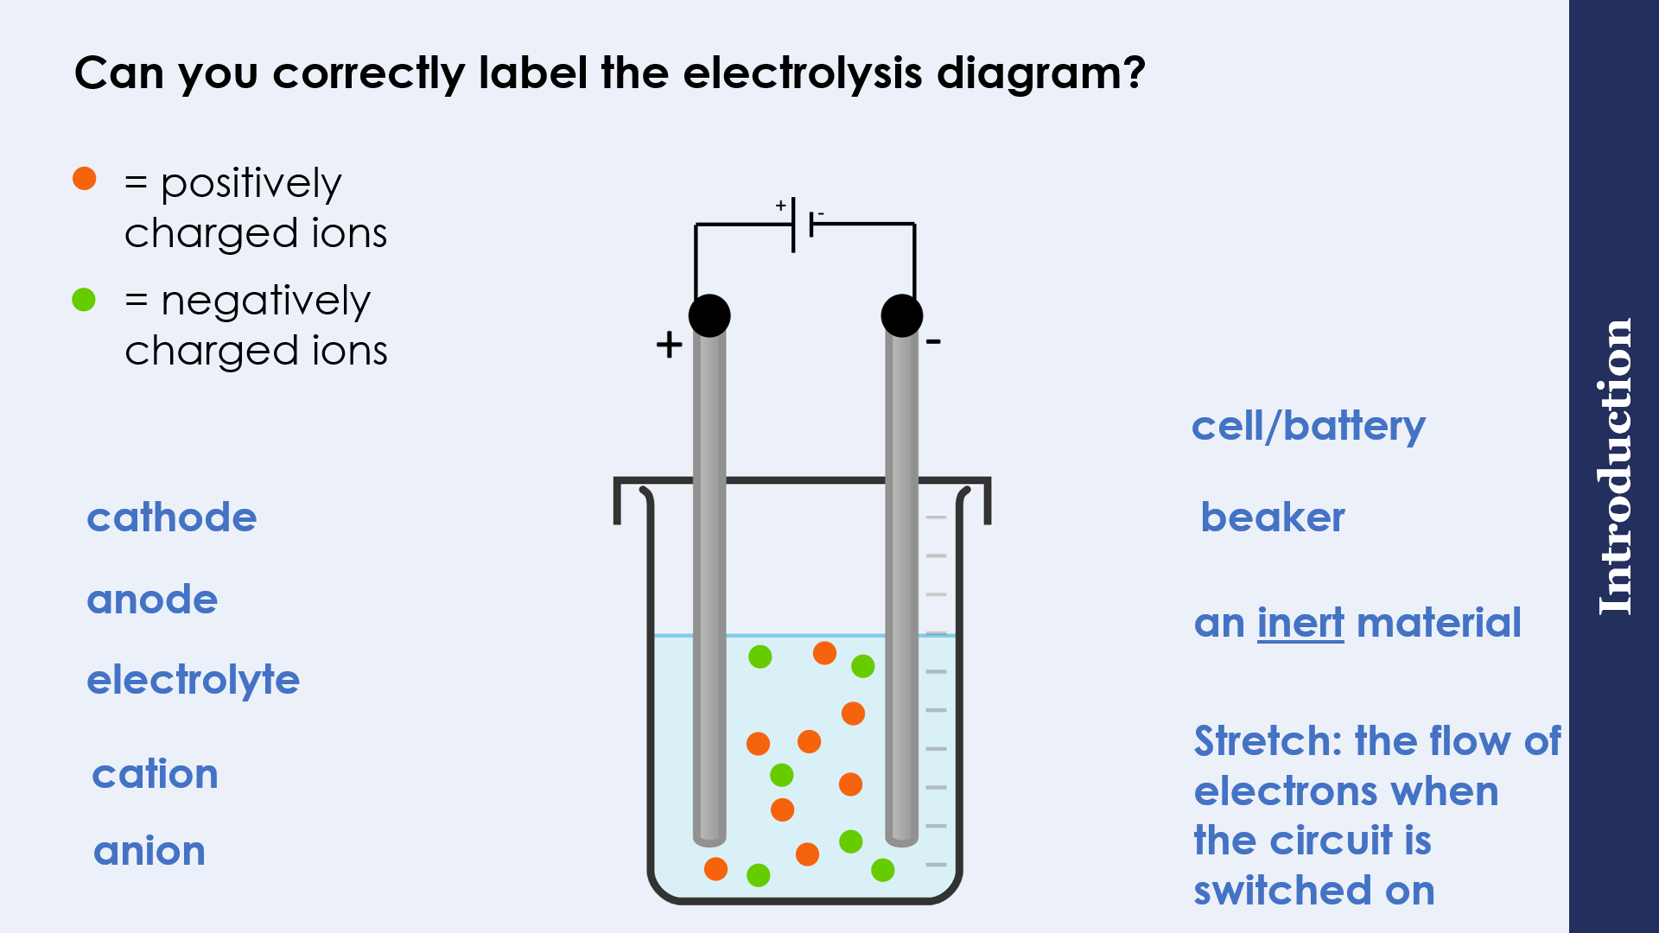
We:
A scientist carried out the electrolysis of lithium chloride.
Describe what will happen when the current is switched on.

You:
A scientist carried out the electrolysis of magnesium oxide.
Describe what will happen when the current is switched on.

Exit Ticket

- Which answer correctly describes the 'anode'?
- A. a positive ion
- B. a negative ion
- C. the positive electrode
- D. the negative electrode

2.Which answer correctly explains why electrolysis will not work with solid sodium chloride?
- A. Solid sodium chloride doesn't conduct electricity because the ions cannot move in a solid
- B. Solid sodium chloride doesn't conduct electricity because the particles cannot move in a solid
- C. Solid sodium chloride doesn't conduct electricity because the electrons cannot move in a solid
- D. Electrolysis will work with solid sodium chloride

3. Which answer below describes the electrolyte?
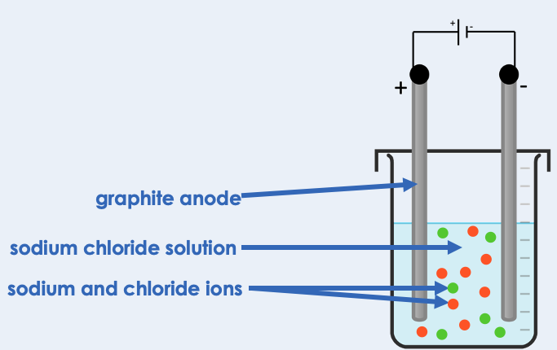
- A. graphite anode
- B. sodium chloride solution
- C. sodium and chloride ions
- D. the entire diagram

Extracting Metals by Electrolysis
Do Now:
1. What happens to metal atoms, that causes them to form positive ions?
2. What is another name for positive ions?
3. Write the electronic configuration of a sodium atom.
4. Write the electronic configuration of a sodium ion.
5. Which electrode will attract positive ions in an electrolysis set-up?
Drill:
1. Define ‘electrolysis’
2. Explain why electrolysis cannot be carried out with solid ionic substances
Read Now:
The extraction of minerals, metals and fuels from the Earth has been happening for thousands of years, and humans are doing more and more of it each year. The average person in the UK uses roughly 26 tonnes of raw materials each year. That is the equivalent of the weight of four and a half elephants worth! All of these mines are putting pressure on the natural world. Active mines all over the world cover an area that is about five times the size of Wales. If we were to suddenly stop mining, there would be an energy crisis for many countries, especially those that depend on coal for electricity. 35% of the world still rely on coal for this purpose. In Europe, we would be affected slightly less as we only depend on coal for 15% of our electricity supply.
1. What mass of raw materials from mines does the average person in the UK use each year?
2. Give one reason why we cannot suddenly stop mining, even though it is putting pressure on the natural world?
3. What percentage of electricity in Europe is generated using coal?
4. Define the words in bold.
Task
Fill in the missing words
- Aluminium ore is called __________.
- Bauxite can be purified to produce _______________ ________, Al₂O₃.
- Aluminium metal can be obtained from aluminium oxide by ____________________.
- The ions in aluminium oxide need to be free to ______ for electrolysis.
- It would be too _______ to melt the ore for electrolysis, because this would require a lot of __________.
- Instead, the aluminium oxide is dissolved in __________, so that a solution is made that has a much lower melting point.
- Carbon is used as the positive _________.

Drill

- What is aluminium ore called?
- State the formula for aluminium oxide.
- Which process is used to extract aluminium from aluminium oxide?
- Why does an ore need to be molten for electrolysis to take place?
- Why isn’t aluminium oxide melted in order for electrolysis to be carried out?
- What is done in order for the ions in aluminium oxide to be able to move during electrolysis?
- Why isn’t aluminium extracted from it’s ore by displacement reaction with carbon?
- What method is used to extract copper from its ore?
- What method is used to extract gold from its ore?
- Why is electrolysis an expensive process?

We: Explain why aluminium is not extracted using displacement with carbon.

You: Explain why aluminium oxide is dissolved in cryolite for electrolysis rather than being melted.

Exit Ticket

- Aluminium is extracted by electrolysis.
Which answer best describes why aluminium cannot be extracted from its ore by heating aluminium oxide with carbon?
- A. because aluminium is less reactive than hydrogen
- B. because aluminium is more reactive than carbon
- C. because aluminium is too reactive

- Why don't we usually carry out electrolysis on molten aluminium ore?
- A. It is expensive to heat the ore to a high enough temperature to melt it.
- B. Electrolysis can be carried out on solid aluminium ore.
- C. It is too expensive to dissolve the aluminium ore in molten cryolite

Electrolysis of Molten Ionic Compounds

Do Now:
1. State the name of the two electrodes in an electrolysis set-up.
2. State the charge on these electrodes.
3. Give one industrial use of electrolysis.
4. Aluminium oxide, Al₂O₃, is an ore of aluminium. Calculate the relative formula mass of aluminium oxide.
5. State the formula for an aluminium ion.

Drill:
- State the formula for an oxide ion.
- Which electrode would an oxide ion be attracted to?
- State the formula for a hydrogen ion.
- What type of substance always contains hydrogen ions?

Read Now:
Many companies are busy coming up with new ideas to help us move to a more sustainable future. One way of doing this would be by using electric cars and motorcycles instead of transport fuelled by fossil fuels. In Argentina, a student called Santiago Hernandez had an idea when he was studying the topic of electrolysis. He wondered if it could be used to propel a vehicle. Now, he has invented an electric motor which runs on salt water, with no other fuel needed. The design will need more modifications before it will produce enough electricity for full-size vehicles.
1. State one change that we could make to our lifestyles towards a more sustainable future.
2. Where is Santiago Hernandez from?
3. What did Santiago think that electrolysis could be used for?
4. What does Santiago's motor need to work?
5. Why isn't Santiago's motor ready to use in cars now?
Complete the table.
Electrolyte name | Ions in the electrolyte | Ion discharged at the cathode | What would be observed at the cathode? | (HT only) Half equation at the cathode
Molten lithium fluoride
Molten potassium chloride

Drill

- What is a cation?
- What is an anion?
- Name the positive ion present in molten lithium chloride.
- Name the negative ion present in molten beryllium oxide.
- What is produced when a positive ion is discharged at an electrode?
- What is produced when a negative ion is discharged at an electrode?
- What is observed when a chloride ion is discharged?
- At which electrode will a positive ion be discharged?
- At which electrode will a negative ion be discharged?
- (HT only) Write a half equation to represent the discharge of a sodium ion (Na⁺).

We:
A scientist carried out the electrolysis of molten sodium chloride.
- Describe what will occur at each electrode.
- HT only – Write half equations to describe the discharge of ions at each electrode

You:
A scientist carried out the electrolysis of molten potassium bromide.
- Describe what will occur at each electrode.
- HT only – Write half equations to describe the discharge of ions at each electrode

Exit Ticket

- Sodium ions move to the negative electrode. Choose the best explanation for this.
- A. Sodium electrons are negative so they are attracted to the negative electrode
- B. Sodium ions are positive so they are attracted to the negative electrode
- C. Sodium ions are negative and are attracted to the negative electrode

- Molten lead bromide was electrolysed using inert electrodes. Choose what was produced at the positive electrode (anode).
- A. Bromine
- B. Bromide ions
- C. Lead

- Choose the correct statement.
- A. Negative ions gain electrons from the positively charged cathode
- B. Positive ions gain electrons from the negatively charged cathode
- C. Negative ions lose electrons at the negatively charged cathode

Do Now:
Electrolysis in Solutions
- Which is produced at the electrode in electrolysis? ions or elements?
- True or false? A metal is produced at the anode.
- (HT only) Write a half equation for the production of oxygen gas at the anode.
- State the ions that make up lead bromide.
- (HT only) Complete the balanced half equation for the process that occurs at the cathode, in the electrolysis of molten lead bromide.
Pb²⁺ + ______ → Pb
Drill:
- Molten magnesium chloride is electrolysed. State what is produced at the anode and cathode.
- Explain how magnesium is formed at the negative electrode (cathode).

Read Now:
In the late 18th century, scientists were fascinated by electricity. Ben Franklin conducted a famous experiment where he used a kite to draw electricity from lightning in 1752. Leyden jars, invented in 1746, could store charge and produce a spark of electricity. Doctors were treating patients with electric shocks for many different ailments. However, to really make progress, scientists would need to be able to produce a continuous flow of current. This was not available until 1800, when Alessandro Volta invented the electric pile, which led to the development of the first ever battery. Soon afterwards, Willian Nicholson and Anthony Carlisle used the current generated by this battery to decompose water into hydrogen and water.
- What did Ben Franklin do with a kite?
- What did Leyden jars do?
- How did doctors use electricity in the late 18th century?
- Who invented the electric pile?
- What did William Nicholson and Anthony Carlisle use a battery for?
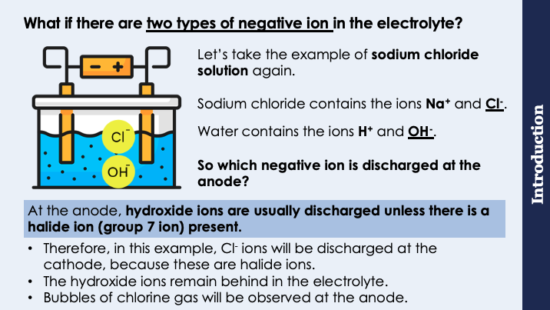
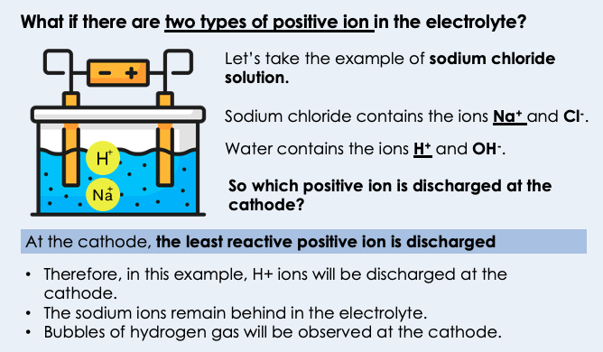

Drill

- What is the charge on an anode?
- What is the charge on a cathode?
- List the ions in molten lithium fluoride.
- List the ions in lithium fluoride solution.
- If the two positive ions in solution are K⁺ and H⁺, which positive ion would be discharged at the cathode?
- Explain your answer to question 5.
- If the two negative ions in solution are OH⁻ and SO₄²⁻, which negative ion would be discharged at the anode?
- Explain your answer to question 7.
- List the ions present in water.
- (HT only) Write two half equations to show what happens at the electrodes in the electrolysis of molten sodium chloride.

We:
A student carries out the electrolysis of a solution of copper (II) sulfate (CuSO₄).
(a) List the ions present in the electrolyte.
(b) Explain which ions will be discharged at each electrode.
(c) Describe what the student would observe when carrying out their electrolysis.

You:
A student carries out the electrolysis of a solution of hydrochloric acid (HCl).
(a) List the ions present in the electrolyte.
(b) Explain which ions will be discharged at each electrode.
(c) Describe what the student would observe when carrying out their electrolysis.

Exit Ticket

- A student carried out electrolysis of potassium chloride solution. What was produced at the negative electrode (cathode)?
- A. Potassium
- B. Chlorine gas
- C. Hydrogen gas
- D. Oxygen gas

- In the electrolysis of copper chloride solution, which ions are in the electrolyte?
- A. Cu²⁺, Cl⁻, H⁺, O²⁻
- B. Cu²⁺, Cl⁻, H⁺, OH⁻
- C. CuCl₂, H₂O
- D. OH⁻, H

- Does water react during the electrolysis of an aqueous solution?
- A. Yes, always
- B. No
- C. Sometimes, it depends on the solution

Required Practical: Electrolysis of Aqueous Solutions
Do Now:
1. What is used to measure current in a circuit?
2. State the ions that water produces in a solution.
3. Describe the test for hydrogen gas.
4. Sodium chloride solution contains two types of positive ions, hydrogen ions (H+) and sodium ions (Na+). Why is hydrogen produced at the negative electrode and not sodium?
5. Balance the half equation H⁺ + e⁻ → H₂

Drill:
- State the ions in molten sodium chloride
- State the ions in sodium chloride solution.
- Deduce which ions would be discharged at each electrode in the electrolysis of sodium chloride solution.
Read Now:
If you can quench your thirst by walking to the kitchen for a glass of water, then you are one of the lucky ones. Almost 2 billion people worldwide do not have easy access to drinking water, according to the World Health Organisation (WHO). Half of the world’s population could be living in areas that are facing water scarcity by 2025, according to UNICEF. Scientists are busy thinking of solutions. One option is to take salty water from the ocean and make it drinkable using a process called desalination. Desalination requires a lot of energy, but it may be possible to power the process using solar energy. Other solutions include capturing water from the air or from the sea, and there are even technologies that can produce potable water from human faeces!

1. How many people worldwide do not have easy access to drinking water?
2. What proportion of the world’s population are facing water scarcity by 2025?
3. Define the words in bold.
4. Describe one possible solution to bring clean drinking water to more people worldwide.

Complete the table
Gas to test | Method | Positive result
Oxygen
Hydrogen
Chlorine

Drill

- Define electrolysis.
- What is an electrolyte?
- What is the positive electrode called?
- What is the negative electrode called?
- Why does an electrolyte have to be a liquid?
- What electrode does a cation move towards?
- What electrode does an anion move towards?
- At which electrode does oxidation take place?
- At which electrode does reduction take place?
- (HT only) Write a half equation to show what happens when chloride ions are discharged at the anode.

Task
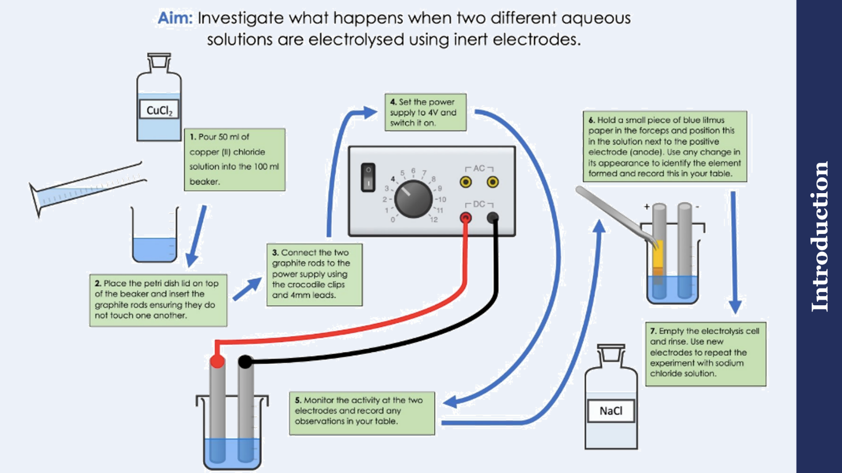

We:
A student had a hypothesis ‘The electrolysis of sodium chloride solution produces a sodium metal at the negative electrode and chlorine gas at the positive electrode’
- What observation would a student make if chlorine gas was produced at the positive electrode?

- What observation would a student make if sodium was produced at the negative electrode?

- When the student carried out the electrolysis experiment, she observed bubbles at both electrodes. Explain this observation.

You:
A scientist had a hypothesis ‘The electrolysis of magnesium chloride produces magnesium at the negative electrode and chlorine at the positive electrode’
- What observation would a scientist make if chlorine is produced at the positive electrode?

- What observation would a scientist make if magnesium is produced at the negative electrode?

Complete the table to suggest whether the hypothesis is correct or incorrect.
Hypothesis about what will happen at the anode | Correct or Incorrect?
Hypothesis about what will happen at the cathode | Correct or Incorrect?

Exit Ticket

- Which answer is not a reason that graphite is used for electrodes?
- A. Graphite is an inert material
- B. Graphite is a simple covalent substance
- C. Graphite is a good conductor of electricity

- What will a student observe at the negative electrode when carrying out the electrolysis of sodium chloride?
- A. A solid will form (sodium metal)
- B. A gas will form (chlorine gas)
- C. A gas will form (hydrogen gas)

- A gas is collected at the negative electrode. When a lit splint is placed in the gas, a squeaky pop sound is heard. What is the gas?
- A. Hydrogen
- B. Oxygen
- C. Chlorine

Obtaining Raw Materials

Do Now:
      - Define ‘potable’ water.
      - Soda-lime glass is made by heating a mixture of which 3 substances?
      - A copper ore with a mass of 70 g contains 20% copper. What is the mass of copper in the ore?
      - What is meant by ‘sustainable development’.
      - State one non-renewable source of energy.

Drill:
- Write a word equation for the reaction of copper with oxygen to form copper oxide.
- Write a balanced chemical equation for the reaction of copper with oxygen to form copper oxide.

Read Now:
Small sea creatures called bloodworms can burrow several metres down through the ocean floor. Scientists have learned that this is partly due to their remarkable jaws, which are made from a high proportion of copper! The jaws act like a composite material, like fibreglass or rubber filled reinforced tyres. A single protein is responsible for forming this jaw material, using copper from the environment. Researchers hope that by studying this material, they can improve other composite materials like concrete.
1. Why can bloodworms burrow several metres down through the seabed?
2. What metal is contained in the jaws of a bloodworm?
3. State an example of a composite material.
4. What do researchers hope to gain by studying the jaws of a bloodworm?
5. Define the word in bold.
Drill

- State a use of copper metal.
- Are copper ores renewable or non-renewable?
- What word is given to a copper ore containing a low percentage of copper?
- State one disadvantage of mining copper ores.
- List two methods that can be used to effectively extract copper from low-grade copper ores.
- Define bioleaching.
- Define phytomining.
- When bacteria feed on are ore, what do we call the solution of metal ions that they produce?
- What process is used to extract pure copper metal from a copper sulphate solution?
- At which electrode will copper metal form in electrolysis?

We:
Soil near copper mines is often contaminated with low percentages of copper compounds.
Phytomining is a new way to extract copper compounds from soil.
Describe how copper compounds are extracted by phytomining.

You:
Phytomining is used to obtain copper from land that contains very low percentages of copper compounds.
Describe how copper compounds are extracted by phytomining.

- State the name of the process where plants are used to extract metals from compounds.
Exit Ticket

- A. Phytomining
- B. Bioleaching
- C. Mining

2 Copper is now extracted from ores containing a low percentage of copper compounds. Why is this?
- A. Other methods are too expensive
- B. Copper ores are becoming scarce
- C. So that electrolysis can be carried out

3 Why is phytomining preferable to traditional mining of copper ores?
- A. It results in less destruction of habitats
- B. It is faster
- C. It is more expensive

Recycling Metals
Do Now:
- State a use of copper metal.
- State one disadvantage of traditional mining of metal ores.
- Name one metal that does not need to be extracted from an ore
- Glass is made from limited raw materials. Name one thing that people can do to reduce the amount of raw materials we use for glass products
- (HT) Define bioleaching.

Drill:
- Copper oxide is an ore of copper with the formula CuO. Calculate the relative formula mass of copper oxide.
- Calculate the percentage composition of oxygen in CuO.

Read Now:
A new battery recycling service in Portsmouth has been a massive success. 750 kg of batteries were collected by the City Council’s battery recycling service in just the first 2 months of the service running. The types of batteries that can be recycled include regular household batteries, laptop batteries, and batteries from hearing aids. After collection, the batteries are sorted so that as much material as possible can be recovered to make new products. Batteries contain toxic metals such as mercury and lead which can do great harm to the environment and the health of organisms. By recycling, these materials can be used in new products, and they don’t end up in landfill.
- What does this new service in Portsmouth do?
- What mass of batteries was collected in the first 2 months?
- What kinds of batteries are collected by this new service?
- Why is it important to recycle old batteries?
- Define the word in bold.

Recycling metals involves collecting used metal items and turning them into new metal items
To do this:
- Scrap metal is collected and transported to a sorting centre
- Items are broken up, and sorted into different kinds of metals
- Other materials such as plastic are removed
- The metals are melted down
- The metals are recast into new items

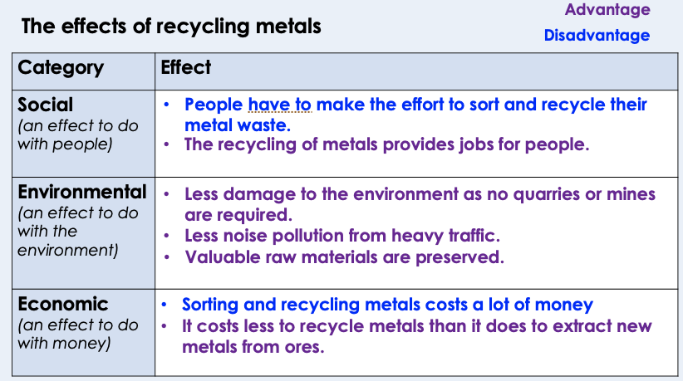
Drill

- What does recycling metals involve?
- What does it mean to recast a molten metal?
- Describe a social advantage of recycling metals.
- Describe a social disadvantage of recycling metals.
- Describe an environmental advantage of recycling metals.
- Describe an economic advantage of recycling metals.
- Describe an economic disadvantage of recycling metals.

We:
Aluminium metal is used to make drinks cans. It is obtained from ores within the Earth’s crust by electrolysis. Aluminium cans can be recycled.
Explain why aluminium should be recycled.

You:
Aluminium metal is used to make drinks cans. It is obtained from ores within the Earth’s crust by electrolysis. Aluminium cans can be recycled.
Explain why aluminium should be recycled.

Exit Ticket

- Choose which describes a method used to recycle metals.
- A. Reforming then melting
- B. Recasting then reformed
- C. Melting then recasting

- Steel cans should not be disposed of in landfill because…
- A. the metal can be recycled instead
- B. the iron can form iron ore
- C. the landfill costs more than recycling

- Which of the following is a social advantage of recycling metals?
- A. Recycling metals is less costly than extracting metals from ores
- B. Recycling metals provides jobs for people
- C. Recycling metals preserves valuable natural ores.

Independent Practice
Prior Knowledge Review 71
Extracting Less Reactive Metals 75
Prior Knowledge Review: Ions, Ionic Bonding and Deducing Ionic Formulae 79
Ionic Bonding Exam Question: High Demand 82
Ionic Bonding Exam Question: Low Demand 85
(HT) Ionic Equations and Displacement Reactions 88
(HT) Writing Half-Equations 92
(HT) Writing Ionic Equations for the Reactions of Acids and Metals 96
Introduction to Electrolysis 100
Extracting Metals by Electrolysis 105
Electrolysis of Molten Ionic Compounds 109
Electrolysis in Solutions 113
Required Practical – The Electrolysis of Aqueous Solutions 118
(HT) Obtaining Raw Materials 124
Recycling Aluminium Exam Question 128
Recycling Copper Exam Question 131
Recycling Metals 134

Prior Knowledge Review
Section A:
- Select the correct chemical formula to complete the table below.

OH⁻ HCl NaCl H⁺ HNO₃ H₂SO₄

Chemical name | Chemical formula
Hydrochloric acid

Nitric acid

Sulfuric acid

Sodium chloride

Hydrogen ions

Hydroxide ions

- Below shows the general equation for the reaction of a metal and an acid.

Metal + acid salt + hydrogen
Complete the word equations below:
- Magnesium + hydrochloric acid → magnesium chloride + ______________

- Zinc + hydrochloric acid → ____________________ + ___________________

- Calcium + nitric acid → calcium nitrate + ____________________

- Iron + sulfuric acid → iron sulphate + ____________________

- Copper + nitric acid → ____________________ + ____________________

- __________________ + __________________ → potassium nitrate + hydrogen

- __________________ + __________________ → calcium sulphate + hydrogen

- __________________ + __________________ → zinc chloride + hydrogen

- Match each test with the correct description.

Test for hydrogen gas |  | Place universal indicator and the colour will change
Test for carbon dioxide gas |  | Place a lit splint in the sample and a squeaky pop sound is produced
Testing the pH of a solution |  | Shake the sample with lime water and the colour changes to cloudy

- Neutralisation reactions are when acids are neutralised by alkalis or bases to produce a salt and water. Bases are insoluble metal hydroxides (for example, zinc hydroxide) and metal oxides. Alkalis are soluble metal hydroxides (for example, sodium hydroxide) that release OH⁻ in water.

Complete the neutralisation reaction word equations below:

- Acid + base → ____________________ + water

- Hydrochloric acid + calcium carbonate → ____________________ + carbon dioxide + water

- Nitric acid + sodium hydroxide → sodium nitrate + ____________________

- Potassium hydroxide + sulfuric acid → ____________________+ ____________________

- Nitric acid + copper carbonate → _________________ + ________________ + ________________

- ____________________ + ____________________ → magnesium chloride + water

Section B
- Some metals are unreactive, this means that… _______________________________
_____________________________________________________________________________.

- Some metals are very reactive, this means that… _____________________________
_____________________________________________________________________________.

potassium
sodium
lithium
magnesium
zinc
iron
- This table shows the reactivity series of some metals.

The most reactive metal shown on this reactivity series is _______________________ and the least reactive metal is _______________________ .

- Describe what the reactivity series shows.
Include examples of metals in your answer.
_______________________________________________________________________________
_______________________________________________________________________________
_______________________________________________________________________________

- Magnesium can be oxidised.
- Write a definition for oxidation.
___________________________________________________________________________

- Write the word equation for this reaction.
___________________________________________________________________________

- Write a metal that is more easily oxidised than magnesium.
Explain your answer.
___________________________________________________________________________
___________________________________________________________________________

- When magnesium is added to dilute nitric acid in a test tube, a fizzing sound and bubbles are produced.

Suggest what would be observed if zinc was added to nitric acid in a test tube. Explain your answer.

Use information from the reactivity series.
_______________________________________________________________________________
_______________________________________________________________________________
_______________________________________________________________________________

Section C
A student tested the reactivity of three metals. They used the method below.
- Place 2 g of magnesium powder in a test tube
- Add 5 cm³ of each chloride solution to each test tube
- Observe whether a reaction takes place
- Repeat with copper powder and calcium powder

The results are shown in the table below.
 | Was a reaction observed?
 | Magnesium | Copper | Calcium
Magnesium chloride | No | No | Yes
Copper chloride | Yes | No | Yes
Calcium chloride | No | No | No

- Use the results shown in the table to place these metals in order of reactivity.

Most reactive ________________________

________________________

Least reactive ________________________

- (a) State the dependent variable in this experiment.
_______________________________________________________________________________

(b) Suggest what could have observed when a chemical reaction took place.
_______________________________________________________________________________

- Suggest why potassium should not be used in this experiment.
_______________________________________________________________________________

- (a) Is magnesium chloride an ionic or covalent substance? Explain your answer.
_______________________________________________________________________________

- Compare magnesium chloride solution and molten (melted) magnesium chloride.
_______________________________________________________________________________
_______________________________________________________________________________
_______________________________________________________________________________

Extracting Less Reactive Metals
Section A:
            - Complete this sentence. The reactivity series is a list of…
___________________________________________________________________________
___________________________________________________________________________

- Using the reactivity series, state all the metals that are more reactive than carbon.

___________________________________________________________________________
___________________________________________________________________________

- Write the correct words in the gaps to complete the sentences.

- Oxidation involves reacting with ______________________ to form an oxide.
- An oxidising agent causes the ______________________ of a substance.
- Reduction of a compound involves the loss of ______________________ .
- A reducing agent causes the ______________________ of a substance.

- This question is about a displacement reaction.

- Complete the displacement reaction below.

Zinc oxide + carbon ______________________ + ______________________

- Complete the balanced symbol equation below.

ZnO + C → ____________ + ____________

- Define ‘displacement reaction’.
___________________________________________________________________________
___________________________________________________________________________
- Explain why carbon displaces zinc in this reaction.
___________________________________________________________________________
___________________________________________________________________________

- State what has been reduced in this reaction. Explain your answer.
___________________________________________________________________________
___________________________________________________________________________

Section B
- Choose which metal is found as pure metal in the Earth,
- Tick (✓) one box.
  Sodium | Platinum | Zinc
- Explain your answer to (a).
___________________________________________________________________________

- Rocks can contain metal ores.

- Define ‘ore’.
___________________________________________________________________________

- Explain why aluminium and magnesium are always found as ores in the Earth and not as pure metals.
___________________________________________________________________________
___________________________________________________________________________

- Using the reactivity series, complete the word equations below.

If there is no reaction, write ‘NO REACTION’ and explain why.

- Aluminium oxide + carbon _________________________________________
- Silver oxide + carbon _____________________________________________
- Carbon + magnesium oxide ________________________________________
- Iron oxide + carbon _______________________________________________
- Carbon + sodium oxide ___________________________________________
- Carbon + lead oxide ______________________________________________
- Calcium oxide + calcium __________________________________________

- Complete the table below to state what is being reduced and what is being oxidised in each reaction.

Displacement reaction | What is reduced? | What is oxidised?
Copper oxide + carbon

Lead oxide + carbon

Zinc oxide + carbon

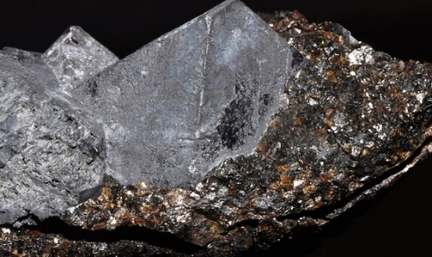
Section C

Galena, shown in the image, is a mineral ore that contains lead sulfide. Galena is the main ore of lead and has been mined for centuries.
Image source: https://commons.wikimedia.org/wiki/File:Galena,_sphalerite.jpg

- Write the compound formula for lead sulfide.
___________________________________________________________________________

- Calculate the relative formula mass of lead sulfide.
___________________________________________________________________________

- Calculate the percentage by mass of lead in lead sulfide.
Give your answer to 1 decimal place.
___________________________________________________________________________
___________________________________________________________________________

- Is lead sulfide an ionic or covalent compound? Explain your answer.
___________________________________________________________________________
___________________________________________________________________________
- Below shows a two-step method for extracting lead from lead sulfide.

Reaction 1 Lead sulfide + oxygen lead oxide + sulfur dioxide

Reaction 2 Lead oxide + carbon lead + carbon dioxide

- Write out the balanced symbol equations for reaction 1 and reaction 2.

Reaction 1 _________________________________________________________________________

Reaction 2 _________________________________________________________________________

- State which reaction shows the oxidation of lead. Reaction _____ .

- State which reaction shows the reduction of lead. Reaction _____ .

- Copper was used instead of carbon in reaction 2. Explain why there was no reaction.
___________________________________________________________________________
___________________________________________________________________________
___________________________________________________________________________

Prior Knowledge Review: Ions, Ionic Bonding and Deducing Ionic Formulae
Section A:
- Match each key word with the correct definition.

Element |  | A substance made from only one type of atom
Atom |  | A negatively charged, sub-atomic particle that orbits the nucleus of an atom
Ion |  | A charged particle. It can have a positive or negative charge.
Electron |  | The smallest part of an element than can exist

Write the correct words in the gaps to complete the sentences.
- When a metal atom loses an electron a _____________________________ charged ion is formed.
- When a non-metal atom gains an electron a _____________________________ charged ion is formed.

- Describe ionic bonding, giving an example.
___________________________________________________________________________
___________________________________________________________________________
___________________________________________________________________________

- Lithium and chlorine react to form the ionic compound, lithium chloride.

- Complete the diagram below to show the electronic configuration of a lithium atom and a chlorine atom.

Li
Cl

- State the number of valence electrons (in the outer shell) in the lithium and chlorine atoms.

Lithium valence electrons __________
Chlorine valence electrons __________

- State which groups these elements are found in the periodic table.

Lithium is in group __________ of the periodic table.
Chlorine is in group __________ of the periodic table.

- Describe the relationship between the number of valence electrons and the periodic table group. Use examples in your description.

___________________________________________________________________________
___________________________________________________________________________
___________________________________________________________________________

- Explain why the noble gases can be said to be in group 8 and group 0 of the periodic table.

___________________________________________________________________________
___________________________________________________________________________
___________________________________________________________________________

Section B

- This question is about sodium chloride.
- Explain why sodium chloride has a very high melting point.
___________________________________________________________________________
___________________________________________________________________________
___________________________________________________________________________
___________________________________________________________________________

- Explain how a sodium atom is different to a sodium ion.
___________________________________________________________________________
___________________________________________________________________________

- State how many valence electrons sodium and chlorine have.
___________________________________________________________________________

- Complete the diagram below to show the ionic bonding between sodium and chlorine.

Cl
Na

- Describe, in terms of electrons, what happens when a sodium atom reacts with a chlorine atom to produce sodium chloride.

___________________________________________________________________________
___________________________________________________________________________
___________________________________________________________________________
___________________________________________________________________________
___________________________________________________________________________
___________________________________________________________________________
___________________________________________________________________________
___________________________________________________________________________
___________________________________________________________________________

Ionic Bonding Exam Question: High Demand
Read the exam style question carefully, then fill in each section below.

Question:
The diagram below shows the outer electrons in an atom of sodium and an atom of oxygen.

Na
O

Sodium forms an ionic compound with oxygen.
Describe, in terms of electron transfer, what happens when two atoms of sodium react with one atom of oxygen.
Give the formulae of the ions formed.
(6)
Section 1: At first glance
1. What command words are used in this question? Circle them clearly.
2. Underline the key information in the question above.
2. How many marks is this question worth?

Section 2: Thinking ahead
Read the question again.
What do you need to know in order to answer this question really well?
Can you split the question into two or more parts?
Are there any labelled diagrams that might help you to show your answer?
What are the key words that you should include in your answer?

Section 3: Space to plan
Use this space to plan your answer.

Section 4: Answer the question
________________________________________________________________________________________________________________________________________________________________________________________________________________________________________________________________________________________________________________________________________________________________________________________________________________________________________________________________________________________________________________________________________________________________________________________________________________________________________________________________________________________________________________________________________________________________________________________________________________________________________________________________________________________________________________________________________________________________________________________________________________________________________________________________________________________________________________________________________________________________________________________

Section 5: Check your answer

In your answer, you should mention
- electrons are transferred from sodium to oxygen
- two sodium atoms each lose one electron
- the sodium atoms form sodium ions (Na⁺ ions)
- the oxygen atom gains 2 electrons
- the oxygen atom forms an oxygen ion (O²⁻ ion)
- the positive and negative ions are held together by electrostatic forces of attraction

Ionic Bonding Exam Question: Low Demand
Read the exam style question carefully, then fill in each section below.

Question:
The diagram below shows the outer electrons in an atom of sodium and an atom of fluorine.
Na
Fl

Sodium forms an ionic compound with fluorine.
Describe what happens when an atom of sodium reacts with an atom of fluorine.
You should describe the transfer of electrons in your answer.
Give the formulae of the ions formed.
(6)
Section 1: At first glance
1. What command words are used in this question? Circle them clearly.
2. Underline the key information in the question above.
2. How many marks is this question worth?

Section 2: Thinking ahead
Read the question again.
What do you need to know in order to answer this question really well?
Can you split the question into two or more parts?
Are there any labelled diagrams that might help you to show your answer?
What are the key words that you should include in your answer?
Section 3: Space to plan
Use this space to plan your answer.

Section 4: Answer the question
________________________________________________________________________________________________________________________________________________________________________________________________________________________________________________________________________________________________________________________________________________________________________________________________________________________________________________________________________________________________________________________________________________________________________________________________________________________________________________________________________________________________________________________________________________________________________________________________________________________________________________________________________________________________________________________________________________________________________________________________________________________________________________________________________________________________________________________________________________________________________________________________________________________________________________________________

Section 5: Check your answer

In your answer, you should mention
- an electron is transferred from sodium to fluorine
- the sodium atom loses one electron
- the sodium atom forms a sodium ion (Na⁺ ion)
- the fluorine atom gains an electron
- the fluorine atom forms a fluorine ion (F⁻ ion)
- the positive and negative ions are held together by electrostatic forces of attraction

(HT) Ionic Equations and Displacement Reactions
Section A:
      - Write a definition for oxidation and reduction in terms of electrons.

Oxidation - ___________________________________________________________________________

Reduction - __________________________________________________________________________

- Using your handout showing the list of common ions and their formulae, complete the table below.
Compound formula | Ions that make up the compound
Mg(NO₃)₂ | Mg²⁺ and 2 NO₃ ⁻
AgNO₃
HCl
Na₂O
CuCl₂
LiOH
CuSO₄
H₂CO₃
Ca(OH)₂
Al(OH)₃

- Using your knowledge of reduction and oxidation, complete the table below:
A | B | Would A need to gain or lose electrons to become B? | How many electrons?
H_{(g)} | H⁺_{(aq)}
Li⁺_{(aq)} | Li_{(s)}
F_{2(g)} | 2F⁻_{(aq)}
2I⁻_{(aq)} | I_{2(s)}
2Cl⁻_{(aq)} | Cl_{2(g)}
Ca_{(s)} | Ca²⁺_{(aq)}
S²⁻ _{(aq)} |  | Lose | 2
 | Mg_{(s)} | Gain | 2
Al³⁺ _{(aq)} |  | Gain

Section B

- State one way in which ionic equations are different to chemical equations.
___________________________________________________________________________
___________________________________________________________________________

- Explain what is meant by the term ‘spectator ions’.
___________________________________________________________________________

- Using the ionic equation below, complete the gaps in the sentences.
Ca_{(s)} + Cu²⁺_{(aq)} → Ca²⁺_{(aq)} + Cu_{(s)}

- Calcium ________ lose 2 electrons to become _______________charged ions.
- This loss of electrons means that calcium is _______________.
- Copper ________ gain 2 electrons to become _______________ atoms.
- This gain of electrons means that copper is _______________.

- Copper reacts with hydrochloric acid.

- Write the word equation for this reaction.

___________________________________________________________________________

- Write the balanced chemical symbol equation for this reaction.

___________________________________________________________________________

- Cross out any spectator ions in the equation in part (b)

- Write the ionic equation for this reaction.

___________________________________________________________________________

- Potassium reacts with magnesium sulphate solution.

- Write the chemical symbol equation for this reaction.

___________________________________________________________________________

- Write the ionic equation for this reaction.

___________________________________________________________________________

Section C
A student did an experiment to extract copper from copper oxide. They used the following method.
- Mix 1g copper oxide with 2g powdered carbon in a test tube
- Heat the mixture for 5 min
- Leave the mixture to cool


Carbon powder and copper oxide are both a dull, black colour.
Copper metal is a red-orange, shiny colour.
- The container of copper oxide has the following hazard symbol.

State what this hazard symbol shows and describe a precaution the student should take when using copper oxide.
______________________________________________________________
______________________________________________________________
______________________________________________________________

- A gas is produced during this reaction.
State the name of this gas and describe how to test for it.
___________________________________________________________________________
___________________________________________________________________________
___________________________________________________________________________

- Suggest what would be observed in the test tube at the end of this experiment.
___________________________________________________________________________
___________________________________________________________________________

- Write the balanced chemical equation for the reaction between copper oxide and carbon.
___________________________________________________________________________
- Is this a displacement reaction? Explain how you know.
___________________________________________________________________________
___________________________________________________________________________

- Explain whether copper is reduced or oxidised in this reaction.
___________________________________________________________________________
___________________________________________________________________________
___________________________________________________________________________

(HT) Writing Half-Equations
Section A:

      - State the differences between ionic equations and half equations.
___________________________________________________________________________
___________________________________________________________________________
      - Write out the state symbols below.

(s) - ___________________________ (l) - ___________________________

(aq) - ___________________________ (g) - ___________________________

- Write the definition of a redox reaction.
___________________________________________________________________________
___________________________________________________________________________

- Below shows an ionic equation for a chemical reaction.

2Br_{(s)} + 2Na⁺_{(aq)} + 2I⁻_{(aq)} → 2Na⁺_{(aq)} + Br⁻_{(aq)} + I_{2(s)}

- Is this a displacement reaction? Explain your answer.
___________________________________________________________________________
___________________________________________________________________________

- State what is being reduced and what is being oxidised in the reaction.
___________________________________________________________________________
___________________________________________________________________________

- Is this a redox reaction? Explain your answer.
___________________________________________________________________________
___________________________________________________________________________
- Below shows one half equation for this reaction.

Br_{2 (s)} + 2e⁻ → 2Br⁻_{(aq)}

Write the other half equation for this reaction.

___________________________________________________________________________

Section B
Steps for writing half equations:
- Pick one element that’s on both sides of the equation
- Write down reactant → product, copying from the equation exactly
- Balance the atoms and ions
- Add up the charges on both sides
- Balance the charges with electrons

Using the information in the box, write out half equations for the following ionic equations.

- F_{2(g)} + 2I⁻_{(aq)} → 2F⁻_{(aq)} + I_{2(s)}

___________________________________________________________________________
___________________________________________________________________________
___________________________________________________________________________
___________________________________________________________________________
___________________________________________________________________________
___________________________________________________________________________

- Fe_{(s)} + Pb²⁺_{(aq)} → Fe²⁺_{(aq)} + Pb_{(s)}

___________________________________________________________________________
___________________________________________________________________________
___________________________________________________________________________
___________________________________________________________________________
___________________________________________________________________________
___________________________________________________________________________

- Cl⁻_{(aq)} + Ag⁺_{(aq)} → AgCl_{(s)}

___________________________________________________________________________
___________________________________________________________________________
___________________________________________________________________________
___________________________________________________________________________
___________________________________________________________________________
___________________________________________________________________________

Section C
Fluorine, chlorine, and bromine are in Group 7, the halogens.
As you go down the Group 7 elements, reactivity decreases.
Chlorine reacts with a solution of potassium bromide to produce bromine.

- Write the balanced chemical equation for this reaction.

___________________________________________________________________________

- Write the ionic equation for this reaction.

___________________________________________________________________________

- Write two half equations for this reaction.

___________________________________________________________________________

___________________________________________________________________________

- Explain why this is a redox reaction.
___________________________________________________________________________
___________________________________________________________________________

- Using the periodic table, state how many electron shells a chlorine atom and a bromine atom have.
___________________________________________________________________________
___________________________________________________________________________

- Explain, in terms of electronic structure, why chlorine is more reactive than bromine.
___________________________________________________________________________
___________________________________________________________________________
___________________________________________________________________________
___________________________________________________________________________
___________________________________________________________________________
___________________________________________________________________________
___________________________________________________________________________
___________________________________________________________________________

(HT) Writing Ionic Equations for the Reactions of Acids and Metals
Section A:

- Write the general equation for reaction of a metal and acid.
___________________________________________________________________________

- Complete the table below to show the formulae and ions in different acids.
Name of acid | Molecular Formula | Ions formed when in solution
Hydrochloric acid

Nitric acid

Sulfuric acid

- Complete the sentences below about the salts formed from metal and acid reactions.

- Hydrochloric acid forms salts ending in ‘chloride’.
- Nitric acid forms salts ending in ‘________________________.
- Sulfuric acid forms salts ending in ‘________________________.

- Complete the word equations below:

- Copper + nitric acid → ______________________________________________

- Zinc + hydrochloric acid → __________________________________________

- Aluminium + nitric acid → ___________________________________________

- Lead + sulfuric acid → ______________________________________________

- Sodium + hydrochloric acid → ______________________________________

- Complete the gaps in the equations below

Word equation: calcium + sulfuric acid → calcium sulfate + hydrogen

Chemical equation: Ca_{(s)} + H₂SO_{4(aq)} → CaSO_{4(aq)} + H_{2(g)}

Ionic equation: Ca_{(s)} + 2H⁺_{(aq)} → Ca²⁺_{(aq)} + H_{2(g)}

Half equations: Ca_{(s)} → Ca²⁺ + 2e⁻ (oxidation)
2H⁺_{(aq)} + 2e⁻ → H_{2(g)} (reduction)
Section B

For each of the following reactions of metals and acids, write
- the word equation
Steps for writing half equations:
- Pick one element that’s on both sides of the equation
- Write down reactant → product, copying from the equation exactly
- Balance the atoms and ions
- Add up the charges on both sides
- Balance the charges with electrons
- the chemical equation
- the ionic equation
- the two half equations – labelling each as either reduction or oxidation

Use the guidance in this box for support with writing half equations.

- Lithium and nitric acid

- ___________________________________________________________________________
- ___________________________________________________________________________
- ___________________________________________________________________________
- ___________________________________________________________________________
___________________________________________________________________________

- Magnesium and hydrochloric acid

- ___________________________________________________________________________
- ___________________________________________________________________________
- ___________________________________________________________________________
- ___________________________________________________________________________
___________________________________________________________________________

- Aluminium and hydrochloric acid

- ___________________________________________________________________________
- ___________________________________________________________________________
- ___________________________________________________________________________
- ___________________________________________________________________________
___________________________________________________________________________
Section C
Calcium and hydrochloric acid react to form a salt and hydrogen gas.

- State which salt is produced in this reaction.

___________________________________________________________________________

- Give the test for hydrogen gas.

Describe the result of the test if hydrogen is present.

Test _______________________________________________________________________
___________________________________________________________________________
Result_____________________________________________________________________
___________________________________________________________________________

- Write the ionic equation for this reaction
___________________________________________________________________________
___________________________________________________________________________

- Explain which species is reduced in this reaction.

Write the half equations to support your answer.
___________________________________________________________________________
___________________________________________________________________________
___________________________________________________________________________
___________________________________________________________________________
___________________________________________________________________________

- A scientist carried out this reaction using 40 g of calcium and 72 g hydrochloric acid.

At the end of the reaction 2 g of hydrogen gas was collected.

Calculate the mass of calcium chloride formed.
___________________________________________________________________________
___________________________________________________________________________

- Calculate the relative formula mass of hydrochloric acid.

___________________________________________________________________________
___________________________________________________________________________

Introduction to Electrolysis
Section A:
      - Complete the gaps below.
Electrolysis

Comes from: Electro- -lysis

Electrolysis definition: _________________________________________________________________
________________________________________________________________________________

      - Add the following labels to the diagram below.
The liquid that contains the ions (current is passed through)
Generates a current to flow through the electrolyte
Battery or power source
Positively charged electrode
Negatively charged electrode
Anode
Electrolyte
Cathode

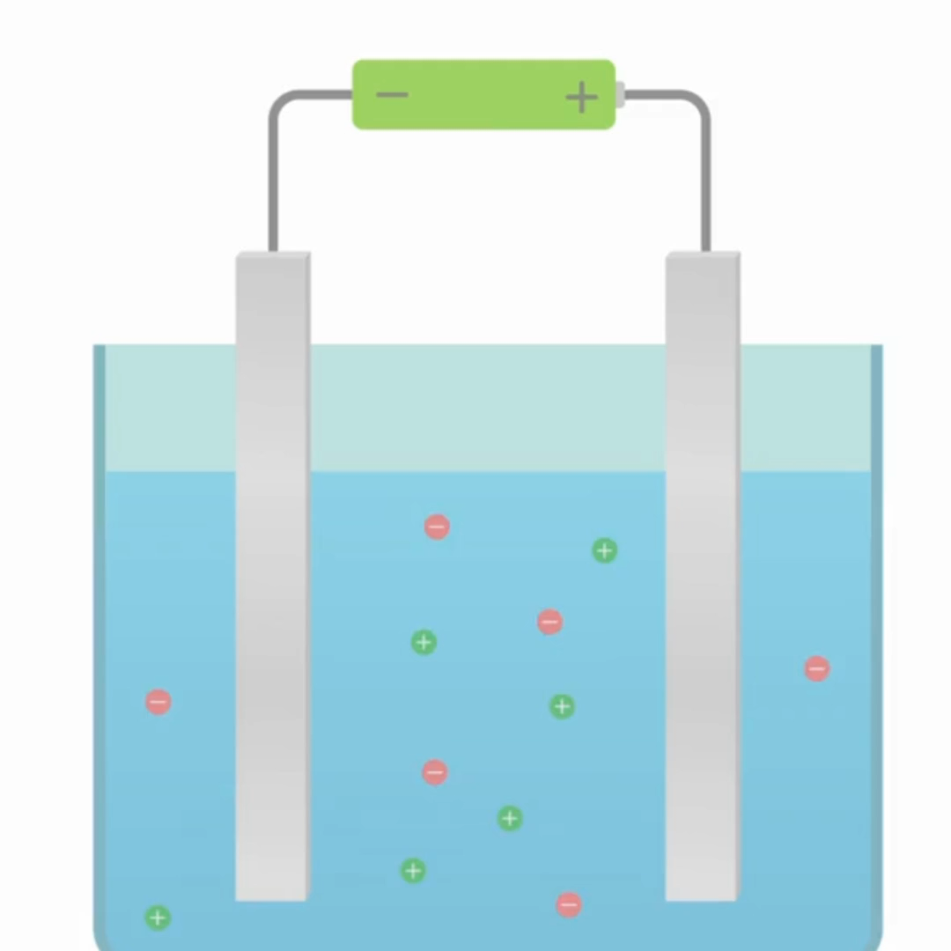

3. Complete the table below to show the ions in different electrolytes.
Name of electrolyte | Positive ion (cation) | Negative ion (anion)
Potassium chloride

Zinc nitrate

Iron oxide

- Complete the sentences below.

- During electrolysis, passing an electric current through electrolytes causes the ______________________ to move to the electrodes.
- Positively charged ions move to the ______________________ electrode where they receive electrons and are ______________________.
- Negatively charged ions move to the ______________________ electrode where they lose electrons and are ______________________.

- Explain why an ionic compound must be liquid when used as an electrolyte.
___________________________________________________________________________
___________________________________________________________________________
- Explain why liquid ammonia (NH₃) cannot be electrolysed.
___________________________________________________________________________
___________________________________________________________________________
___________________________________________________________________________

Section B
Molten potassium fluoride can be electrolysed.
- Molten potassium fluoride contains ions.

- Explain why molten potassium fluoride can be described as an electrolyte.
___________________________________________________________________________
___________________________________________________________________________

- Write the chemical formula for potassium fluoride. _______________________

- State the ions present in potassium fluoride. _____________________________

- State which electrodes these ions move to during electrolysis.
___________________________________________________________________________

- At the negative electrode (cathode), ions gain electrons and are reduced.

Explain what happens to ions at the positive electrode (anode).
___________________________________________________________________________
___________________________________________________________________________

- State what is formed at each electrode.
Negative electrode _____________________________________________________________
Positive electrode _______________________________________________________________

- Write the half equations to show what happens at both electrodes during the electrolysis of potassium fluoride. (HT Only)
Negative electrode _____________________________________________________________
Positive electrode _______________________________________________________________

- The melting point of potassium fluoride is 858 °C.

- What state is potassium fluoride at room temperature (~25 °C)?
___________________________________________________________________________

- Explain why electrolysis of potassium fluoride cannot take place when it is at room temperature.
___________________________________________________________________________
___________________________________________________________________________

Section C - The table below shows some information about metals and their ores.

Metal | Source | First extracted | Extraction method
Platinum | Found as pure metal in the Earth | Used by ancient civilisations in South America | Removing from rocks
Zinc | Zinc oxide | c.1300 in India | Reduction with carbon
Magnesium | Magnesium carbonate  Magnesium chloride | 1808 by Sir Humphry Davy | Electrolysis

- Explain why platinum is found as pure metal in the Earth
___________________________________________________________________________
___________________________________________________________________________

- Zinc can be extracted from zinc oxide by reduction with carbon.

- Explain why carbon is used to extract zinc from zinc oxide.
___________________________________________________________________________
___________________________________________________________________________

- Write the word equation for this reaction.
___________________________________________________________________________

- Write the balanced symbol equation for this reaction.
___________________________________________________________________________

- Explain why magnesium was extracted much later than zinc and platinum.
___________________________________________________________________________
___________________________________________________________________________

- Electrolysis is used in industry to extract magnesium from magnesium chloride. Graphite can be used as electrodes because graphite is a good electrical conductor.
- Explain why graphite conducts electricity.
___________________________________________________________________________
___________________________________________________________________________

- State what is produced at the anode and cathode when magnesium chloride is electrolysed.
Anode ______________________________ Cathode ______________________________

- Suggest why other chemicals are added to the molten magnesium chloride to decrease the melting point of the mixture.
___________________________________________________________________________
___________________________________________________________________________

Extracting Metals by Electrolysis
Section A:
1. Match each key word with the correct definition.
Solvent |  | The temperature at which a solid substance melts into a liquid
Melting point |  | The process of passing an electric current through a substance, to split it up into its ions.
Electrolysis |  | A liquid that can dissolve a solute to form a solution

2. Complete the table below by adding words from the box.
The Reactivity Series | Reactivity | Method of extraction
Potassium
Sodium
Calcium
Magnesium
Aluminium
Carbon
Zinc
Iron
Lead
Copper
Silver
Gold |  | No extraction needed

Least reactive

Most reactive

Extraction using electrolysis

Extraction by reduction using carbon

- State two differences between extraction using electrolysis and extraction using carbon reduction.
- ___________________________________________________________________________
___________________________________________________________________________
2. ___________________________________________________________________________
___________________________________________________________________________

- Explain why reduction using carbon cannot be used to extract aluminium from aluminium oxide.
___________________________________________________________________________
___________________________________________________________________________

- Explain why electrolysis of solid aluminium oxide cannot work.
___________________________________________________________________________
___________________________________________________________________________
Section B

Aluminium can be extracted from its ore, aluminium oxide using electrolysis.
- State the chemical formula for aluminium oxide.
___________________________________________________________________________

- State the ions present in aluminium oxide.
___________________________________________________________________________

- During the electrolysis of aluminium oxide, describe what happens at each electrode.

Include:
- which ions move to each electrode
- whether electrons are lost or gained
- what is reduced and what is oxidised
- what is formed at each electrode.
___________________________________________________________________________
___________________________________________________________________________
___________________________________________________________________________
___________________________________________________________________________
___________________________________________________________________________
___________________________________________________________________________

- For the electrolysis of aluminium oxide, cryolite is added to the electrolyte mixture.

The table below contains the melting points of these compounds.

Compound | Melting point (⁰C)
Aluminium oxide | 2072
Cryolite | 980

Explain why a mixture with cryolite is used to electrolyse aluminium oxide, using your own knowledge and data from the table.
___________________________________________________________________________
___________________________________________________________________________
___________________________________________________________________________
___________________________________________________________________________
___________________________________________________________________________
___________________________________________________________________________

Section C
Bauxite can contain between 16% to 25% aluminium.
- Calculate the relative formula mass of aluminium oxide.
___________________________________________________________________________
___________________________________________________________________________

- Calculate the percentage by mass of aluminium in aluminium oxide.
___________________________________________________________________________
___________________________________________________________________________

- A particular sample of bauxite found in Southern France contained 23 % aluminium.

- Calculate the mass of aluminium in a 1.53 kg sample of this particular bauxite sample. Give your answer in g
___________________________________________________________________________
___________________________________________________________________________
_________________________ g

- Explain how you know that bauxite is not a compound.

Use information in the question and your answer to part (a).
___________________________________________________________________________
___________________________________________________________________________
___________________________________________________________________________

- Explain why pure aluminium is not found in bauxite.
___________________________________________________________________________
___________________________________________________________________________

- Aluminium oxide is found in bauxite and electrolysis is used to extract aluminium.

- Predict what you would observe at each electrode during the electrolysis of aluminium oxide.

Explain your answers.
___________________________________________________________________________
___________________________________________________________________________
___________________________________________________________________________
___________________________________________________________________________

- Describe the disadvantage of not adding cryolite to aluminium oxide when extracting aluminium using electrolysis.
___________________________________________________________________________
___________________________________________________________________________

Electrolysis of Molten Ionic Compounds
Section A:
- Match each key word with the correct definition.
Cation |  | The negatively charged electrode used in electrolysis.
Anion |  | The positively charged electrode used in electrolysis.
Cathode |  | A positively charged ion, e.g. Na⁺
Anode |  | A negatively charged ion, e.g. Cl⁻

- Complete the sentences below to describe the electrolysis of molten magnesium oxide.

- There are Mg²⁺ and O²⁻ ions present in molten magnesium oxide. The ________________ is Mg²⁺ and the ________________ is O²⁻.
- Mg²⁺ ions move towards the ________________ where they are discharged because they have ________________ electrons and been reduced. This forms Mg atoms which appear as solid, silver metal.
- O²⁻ ions move towards the anode where… _______________________
_________________________________________________________________ . This forms… _____________________________________________________ .

- Ions can be discharged at electrodes.

Explain what the term ‘discharged’ means.
___________________________________________________________________________
___________________________________________________________________________

- Complete the table below.

Electrolyte name | Cation in the electrolyte | Anion in the electrolyte | Ion discharged at the cathode  What is observed? | Ion discharged at the anode  What is observed?
Molten lithium bromide |  |  |  | Br ⁻  Brown/red liquid
Molten sodium fluoride
Molten potassium chloride

Section B

Ionic compounds, such as lead chloride (PbCl₂), can be electrolysed when molten.

- Describe a use of electrolysis.
___________________________________________________________________________

- At the negative electrode…
Tick ( ) one box.
- gases are produced.
- ions are reduced.
- anions are present.

- State the ions present in lead chloride.
___________________________________________________________________________

- During the electrolysis of molten lead chloride, describe what happens at each electrode.

Include:
- which ions move to each electrode
- whether electrons are lost or gained
- what is reduced and what is oxidised
- half equations to show this (HT only)
- what is discharged at each electrode.
___________________________________________________________________________
___________________________________________________________________________
___________________________________________________________________________
___________________________________________________________________________
___________________________________________________________________________
___________________________________________________________________________
___________________________________________________________________________
___________________________________________________________________________

- Graphite electrodes were used to electrolyse molten lead chloride because they both conduct electricity and are inert.

Explain why inert substances are used as electrodes.
___________________________________________________________________________
___________________________________________________________________________
Section C

- Electrolysis cannot be carried out using the equipment shown in the diagram below.

- One improvement would be to add a circuit component.

- Draw the symbol of this component below.

- Describe the function of this component.
________________________________________________________________________

- Describe another improvement that could be made so that electrolysis can be carried out
______________________________________________________________________________
______________________________________________________________________________

- Using the correct equipment, molten sodium bromide was electrolysed.

- State what would be produced at the cathode.
______________________________________________________________________________

- Write a half equation to show what happens at the cathode. (HT only)
______________________________________________________________________________

- Explain why a brown gas was seen at the anode.
______________________________________________________________________________
______________________________________________________________________________

- Explain why sodium bromide has a very high melting point of 661⁰C.
______________________________________________________________________________
______________________________________________________________________________

Electrolysis in Solutions
Section A:

- The positive electrode is called the _____________________________.

- The negative electrode is called the _____________________________.

- In an aqueous solution, water molecules break down into…
Tick (✓) one box.
H₂ and OH ions. | H⁺ and OH⁻ ions. | H⁺ and O⁻ ions.

- Write the correct words in the gaps to complete the sentences.

The ions discharged when an aqueous solution is electrolysed using inert ______________________ depend on the relative ______________________ of the elements involved. At the negative electrode, ______________________ is produced if the metal is more reactive than hydrogen. At the positive electrode, ______________________ is produced unless the solution contains halide ions when the halogen is produced.

- Aqueous sodium chloride solution was electrolysed using inert electrode.

- State the ions found in sodium chloride solution.
___________________________________________________________________________

- State which of these ions are attracted to the positive electrode.
___________________________________________________________________________

- At the positive electrode, a gas was produced.
Name this gas an explain why it was produced at the positive electrode.
___________________________________________________________________________
___________________________________________________________________________

- State what was produced at the negative electrode and explain why.
___________________________________________________________________________
___________________________________________________________________________

Section B
A student wanted to carry out electrolysis on different aqueous salt solutions.
They drew a diagram of the equipment used, shown below.
+

- Add the following labels to the diagram: salt solution, power supply, inert electrodes, beaker, anode, cathode.

- Complete the table below.

Use the reactivity series and the list of common ions.
Experiment number | Aqueous salt solution electrolysed | The ions in the aqueous salt solution | Produced at anode | Produced at cathode
A | Potassium iodide
B | Silver nitrate |  | Oxygen
C | Copper sulfate
- The student wanted to test whether hydrogen gas was being produced.

Describe how to test for hydrogen gas.
___________________________________________________________________________
___________________________________________________________________________

- (a) Write the two half equations to show what happens at the electrodes in experiment A in the table. (HT only)
___________________________________________________________________________
___________________________________________________________________________

- Define oxidation and reduction.

Oxidation - _______________________________________________________________
___________________________________________________________________________
Reduction - _______________________________________________________________
___________________________________________________________________________

- Using the half equations you wrote in part (a) state what is being reduced. Explain your answer. (HT only)
___________________________________________________________________________
___________________________________________________________________________
- Using the half equations you wrote in part (a) state what is being oxidised. Explain your answer. (HT only)
___________________________________________________________________________
___________________________________________________________________________

- (a) Complete the two half equations below to show what happens at the electrodes in experiment B in the table. (HT only)

Ensure they are balanced.

At the anode – ______ OH⁻ → O₂ + ______ H₂O + ______ e⁻

At the cathode – ___________________________________________

- Using the half equations you wrote in part (a) state what is being reduced. Explain your answer. (HT only)
___________________________________________________________________________
___________________________________________________________________________
- Using the half equations you wrote in part (a) state what is being oxidised. Explain your answer. (HT only)
___________________________________________________________________________
___________________________________________________________________________

Section C
- Explain why ionic compounds can be electrolysed when liquid.
___________________________________________________________________________
___________________________________________________________________________

- State a difference between molten sodium fluoride and an aqueous solution of sodium fluoride.
___________________________________________________________________________
___________________________________________________________________________

- State what would be produced at the cathode when molten sodium fluoride was electrolysed.

___________________________________________________________________________

- An aqueous solution of sodium fluoride was electrolysed using graphite electrodes.

- State two reasons why graphite was used for the electrodes.
- __________________________________________________________________________
- __________________________________________________________________________

- The product formed at the cathode was different to when molten sodium fluoride was electrolysed. Explain why.
___________________________________________________________________________
___________________________________________________________________________
___________________________________________________________________________

- Fluorine gas is formed at the anode.

Explain why fluorine is a gas at room temperature. Use your knowledge of structure and bonding.
___________________________________________________________________________
___________________________________________________________________________

- Draw a dot and cross diagram to show one molecule of fluorine.

Required Practical – The Electrolysis of Aqueous Solutions
Complete these questions before the practical:

- Label the electrolysis apparatus below using the key words in the box.

cathode anode electrolyte cation anion cell beaker an inert material

Stretch: Use arrows to show the direction of the flow of current in this circuit.
+

- Complete this table to describe any hazards associated with this practical, and the precautions that you will take to keep yourself safe.

Hazard | Precaution | If an accident happens, what should I do?

- Describe a hypothesis for the electrolysis of copper (II) chloride solution.

This hypothesis might be about what you will observe, or what will be formed during the electrolysis investigation.

My hypothesis: ______________________________________________________________________________________________________________________________________________________________________________
- Explain your hypothesis using scientific ideas about electrolysis.

Think about why you have made this particular hypothesis. Don’t forget to include any equations that will help you to explain your hypothesis.

____________________________________________________________________________________________________________________________________________________________________________________________________
____________________________________________________________________________________________________________________________________________________________________________________________________
____________________________________________________________________________________________________________________________________________________________________________________________________

- Record the mass of the anode and cathode before the practical.

Mass of anode:

Mass of cathode:

Complete these questions throughout the practical:
- State the name and formula of the electrolyte that you are using.

_____________________________________ _______________________________________
- List all of the ions that are present in the electrolyte.

_______________________________________________________________________________
- Describe what you expect to observe if your hypothesis is correct.

At the anode: ____________________________________________________________________________________________________________________________________________________________________________________________________
At the cathode:
____________________________________________________________________________________________________________________________________________________________________________________________________
- After you have switched on the current for 2 minutes, describe what you observe.

At the anode: ______________________________________________________________________________________________________________________________________________________________________________
At the cathode:
______________________________________________________________________________________________________________________________________________________________________________
- Use your answer to question 4 to suggest and explain which ion has been discharged at each electrode.

At the anode, I think that the ion discharged is: _______________________________________________________________________________________
This is because
_______________________________________________________________________________________
_______________________________________________________________________________________
At the cathode, I think that the ion discharged is:
_______________________________________________________________________________________
This is because
_______________________________________________________________________________________
_______________________________________________________________________________________
- (HT only) Write a half equation to describe the discharge of ions at each electrode.

At the anode: _______________________________________________________________________________________
At the cathode:
_______________________________________________________________________________________

- After the current has been switched off and unplugged, carefully dry the electrodes and measure their mass.

Mass of anode after electrolysis:
Mass of cathode after electrolysis:

- Describe the change in mass of electrodes. Refer to the measurements you made before electrolysis started.
_______________________________________________________________________________________
_______________________________________________________________________________________

- Explain the change in mass of electrodes (if there was a change in mass)
_______________________________________________________________________________________
_______________________________________________________________________________________
- Circle the correct answer.

My hypothesis was correct/incorrect. I know this because…
_______________________________________________________________________________________
_______________________________________________________________________________________
Complete these questions after the practical:

- A student made a hypothesis, shown below.

“The product at the negative electrode is always a metal when salt solutions are electrolysed using inert electrodes.”
- Explain why the hypothesis is not completely correct
_______________________________________________________________________________________
_______________________________________________________________________________________
- Describe how this hypothesis would be tested.

Include the independent and dependent variables.
_______________________________________________________________________________________
_______________________________________________________________________________________
_______________________________________________________________________________________
_______________________________________________________________________________________

- State what would be produced at the positive electrode when the following solutions were electrolysed:

Copper sulfate solution __________________________________________________________
Potassium fluoride solution _________________________________________________________

- Silver nitrate solution can be electrolysed using inert electrodes to extract silver.

The silver produced during electrolysis fell from the electrode and settled at the bottom of the beaker.

- State what was produced at the negative electrode.
______________________________________________________________________________

- (HT Only) Write a half equation for what was discharged at the negative electrode.
______________________________________________________________________________
- Describe a separating technique that should be used to separate the silver from the mixture.
______________________________________________________________________________
______________________________________________________________________________
This electrolysis experiment was repeated for different durations to investigate how the length of time the solution was electrolysed, affected the mass of silver produced.

The results are shown below.
Time (min) | Mass of silver (g)
0 | 0.0
5 | 0.6
10 | 1.1
15 | 1.7

- Plot these results on the graph paper below.

You should:
- Include axes labels
- Use appropriate scales
- Draw a line of best fit


- Using the graph, describe the results from this investigation.
______________________________________________________________________________
______________________________________________________________________________
______________________________________________________________________________

(HT) Obtaining Raw Materials
Section A:
- Match each key word with the correct definition.

Mining |  | An extraction method that uses plants to absorb metal compounds that are harvested and then burned to produce ash that contains metal compounds.
Phytomining |  | The digging and moving of rock from the Earth.
Bioleaching |  | A process that uses bacteria to produce leachate solutions that contain metal compounds.

- Complete the gaps below.

Low-grade ores contain a very low percentage of the __________________ to be extracted. To extract copper from low-grade copper ores, __________________ and __________________ can be used.

- Describe the effect that mining for ore has on the environment.
___________________________________________________________________________
___________________________________________________________________________

- Explain why copper ores are described as being non-renewable.
___________________________________________________________________________

- State one similarity of phytomining and bioleaching.
___________________________________________________________________________

- Explain why copper ores are becoming more expensive over time.
___________________________________________________________________________
___________________________________________________________________________

- Copper compounds can be extracted from ores.

Describe two methods used to extract copper from copper compounds.
- ________________________________________________________________________
___________________________________________________________________________
- ________________________________________________________________________
___________________________________________________________________________

Section B

- Explain why methods to obtain copper from low-grade ores have been developed.
___________________________________________________________________________
___________________________________________________________________________
___________________________________________________________________________

- Phytomining can be used to obtain copper from low-grade ore in land.

Describe how copper compounds are obtained by phytomining.
___________________________________________________________________________
___________________________________________________________________________
___________________________________________________________________________
___________________________________________________________________________
___________________________________________________________________________
___________________________________________________________________________
___________________________________________________________________________
___________________________________________________________________________

- State a waste gas product made during the phytomining process and explain the environmental impact of this.
___________________________________________________________________________
___________________________________________________________________________
___________________________________________________________________________

- Suggest one reason why phytomining is preferable to mining the land for obtaining copper ores.
___________________________________________________________________________
___________________________________________________________________________

- State one reason why copper should not be disposed of in landfill sites.
___________________________________________________________________________
___________________________________________________________________________

Section C

The greatest demand for copper is in electrical wiring.

Copper can be extracted from low-grade ores such as chalcocite, which contains copper sulfide.

- Copper is used for electrical wiring.

State two properties of copper that make it ideal for electrical wiring.
1. ___________________________________________________________________________
2. ___________________________________________________________________________

- Write the compound formula for copper sulfide. ______________________________

- Copper can be extracted from copper sulfide by heating to over 1000⁰C in a furnace and then blowing in air. Fossil fuels are burned to heat the furnace.

Sulfur dioxide is a product of this reaction.

- Write a balanced word equation for this reaction.
___________________________________________________________________________

- Suggest an environmental impact this process will have.
___________________________________________________________________________

- Bioleaching was used to produce a leachate from chalcocite. The leachate contained copper sulfate solution.

- Define ‘leachate’.
___________________________________________________________________________

- Electrolysis of the copper sulfate solution can be carried out to obtain pure copper.

At which electrode would you expect to see copper forming? Explain your answer.
___________________________________________________________________________
___________________________________________________________________________
___________________________________________________________________________

- Phytomining is not used as frequently as bioleaching to extract copper ores.

Suggest one reason why.
___________________________________________________________________________

Recycling Aluminium Exam Question
Read the exam style question carefully, then fill in each section below.
Question:
Aluminium metal is extracted from an ore called bauxite.
The information below summarises the main steps in the extraction of aluminium from bauxite.
- Aluminium oxide is obtained from the aluminium ore
- The aluminium oxide is purified
- The aluminium oxide is mixed with cryolite
- The mixture is heated to a high temperature (over 950°C) in order to melt it.
- Electrolysis is used to extract pure aluminium from the molten mixture.
Most aluminium is recycled.
To recycle aluminium, scrap metal is melted by heating it to over 700°C.
Suggest why most aluminium is recycled.
Use your knowledge and the information provided in your answer.
(6)
Section 1: At first glance
1. What command words are used in this question? Circle them clearly.
2. Underline the key information in the question above.
2. How many marks is this question worth?

Section 2: Thinking ahead
Read the question again.
What do you need to know in order to answer this question really well?
Can you split the question into two or more parts?
Are there any labelled diagrams that might help you to show your answer?
What are the key words that you should include in your answer?

Section 4: Space to plan
Use this space to plan your answer.

Section 4: Answer the question
_____________________________________________________________________________________________________________________________________________________________________________________________________________________________________________________________________________________________________________________________________________________________________________________________________________________________________________________________________________________________________________________________________________________________________________________________________________________________________________________________________________________________________________________________________________________________________________________________________________________________________________________________________________________________________________________________________________________________________________________________________________________________________________________________________________________________________________________________________________________________________________________________________

Section 5: Check your answer
Points that a great answer might include:
- There are limited resources of aluminium oxide
- A higher temperature is needed to extract aluminium oxide from its ore than to recycle it
- A large amount of energy would be required to extract aluminium from its ore
- It is expensive to extract aluminium from its ore
- To extract aluminium from its ore, this would require mining or quarrying
- To extract aluminium from its ore, it would take longer (or it has more stages)
- To extract aluminium from its ore, it produces more carbon dioxide.
- Recycling saves resources
- It is cheaper to recycle
- Recycling uses less energy
- Recycling only requires the metal to be melted
- Less electricity needs to be used to recycle aluminium.
- Recycling has less on an effect on the environment
- Less habitats are destroyed when recycling is carried out
- Recycling means metals are less likely to end up in landfill
- Recycling is much more sustainable
For 1-2 marks, you might provide 1 or 2 of these points
For 3-4 marks, you have given some of these statements, written clearly, using scientific vocabulary.
For 5-6 marks, you should have provided several of the points above with a detailed explanation. You have used several examples of scientific vocabulary correctly.

Recycling Copper Exam Question
Read the exam style question carefully, then fill in each section below.
Question:

Read the information below.

World demand for copper was approximately 3 million tonnes in 2022. In total, across the world the total amount of copper estimated to be available to extract from the Earth is 870 million tonnes. At the moment, the majority of copper that we use is mined in quarries, and then extracted from ores. To extract copper from its ores, it is heated to a high temperature in a furnace. The furnace is heated using fossil fuels. When heated, the ore forms copper sulfide, CuS. The copper sulfide is then reacted with air to produce copper and sulfur dioxide.

Use the information above, and your own knowledge to justify the statement below:

“Copper should be recycled”

(6)

Section 1: At first glance
1. What command words are used in this question? Circle them clearly.
2. Underline the key information in the question above.
2. How many marks is this question worth?

Section 2: Thinking ahead
Read the question again.
What do you need to know in order to answer this question really well?
Can you split the question into two or more parts?
Are there any labelled diagrams that might help you to show your answer?
What are the key words that you should include in your answer?

Section 4: Space to plan
Use this space to plan your answer.

Section 4: Answer the question
_____________________________________________________________________________________________________________________________________________________________________________________________________________________________________________________________________________________________________________________________________________________________________________________________________________________________________________________________________________________________________________________________________________________________________________________________________________________________________________________________________________________________________________________________________________________________________________________________________________________________________________________________________________________________________________________________________________________________________________________________________________________________________________________________________________________________________________________________________________________________________________________________________

Section 5: Check your answer
Great responses might include some of the following points:
- recycling conserves supplies of ores/natural resources
- copper will be available for longer if we recycle
- at present, copper ores will run out in about 35 years
- recycling conserves supplies of fossil fuels or energy
- less fuel used at a lower cost
- mining scars landscape or produces noise pollution
- mining destroys wildlife habitats
- when we recycle, there is less need to mine ores
- when we recycle, there is less need to burn fossil fuels
- recycling means there is less need to use landfill for waste
- burning fossil fuels produces carbon dioxide or greenhouse gases
- which cause global warming or climate change
- extraction of copper from ores produces sulfur dioxide
- sulfur dioxide causes acid rain
- acid rain can kill trees and fish

For 1-2 marks you might make a couple of points, but you won’t link your ideas together. You might not be very clear in your answer.
For 3-4 marks you might have made a few more points from this list
For 5-6 marks you will have made a number of these points. You will have linked ideas together using words such as ‘so’, ‘whereas’ or ‘however’. Your communication will be clear.

Recycling Metals
Section A:
1. Write definitions for these key words:

Recycling - ___________________________________________________________________________
___________________________________________________________________________

Recasting/reforming - ___________________________________________________________________________
___________________________________________________________________________

2. Give one reason why aluminium should not be put in landfill waste.
___________________________________________________________________________
___________________________________________________________________________

3. There are environmental advantages to recycling metals

State two of these advantages.
1. _________________________________________________________________________
___________________________________________________________________________
2. _________________________________________________________________________
___________________________________________________________________________

- The melting point of copper is 1085⁰C.

State the temperature where copper would be molten. _________________________

5. State two reasons why copper should be recycled.

1. _________________________________________________________________________
___________________________________________________________________________
2. _________________________________________________________________________
___________________________________________________________________________

Section B
1. Describe the process of recycling metals.
___________________________________________________________________________
___________________________________________________________________________
___________________________________________________________________________
___________________________________________________________________________
___________________________________________________________________________
___________________________________________________________________________
___________________________________________________________________________
___________________________________________________________________________
___________________________________________________________________________

2. Evaluate the advantages and disadvantages of recycling metals.

Include social, environmental, and economical factors.
___________________________________________________________________________
___________________________________________________________________________
___________________________________________________________________________
___________________________________________________________________________
___________________________________________________________________________
___________________________________________________________________________
___________________________________________________________________________
___________________________________________________________________________
___________________________________________________________________________
___________________________________________________________________________
___________________________________________________________________________
___________________________________________________________________________
___________________________________________________________________________

Section C
A metal scrap yard contained previously used scraps of iron, copper, and steel.
An electromagnet was used to separate the metals so they could be sorted for recycling.
1. Explain why this mixture needs to be separated before recycling can take place.
___________________________________________________________________________
___________________________________________________________________________

2. State which metal(s) would be attracted to the electromagnet.
___________________________________________________________________________

3. Explain the advantages of using an electromagnet rather than a permanent magnet when separating metals.
___________________________________________________________________________
___________________________________________________________________________
___________________________________________________________________________
___________________________________________________________________________
___________________________________________________________________________
___________________________________________________________________________

4. Compare the composition of steel and iron.
___________________________________________________________________________
___________________________________________________________________________

5. Explain why steel is harder than iron.
___________________________________________________________________________
___________________________________________________________________________
___________________________________________________________________________

6. In the UK, 40% of the metal we use is recycled and the rest is obtained using mining.

- Calculate the percentage of metal we use that has been obtained using mining.
___________________________________________________________________________

- Calculate the simplest ratio of recycled metal to metal obtained by mining.
___________________________________________________________________________

(c)Given the importance of recycling metals, suggest how people could be encouraged to increase the percentage of recycled metals.
___________________________________________________________________________
___________________________________________________________________________
___________________________________________________________________________

